Independent Study

Media disposal and sanitisation

BY

Christopher-Charles Taylor
(0811342)

COURSE TITLE: MSc Computer Security and Forensics (7Safe)

Abstract

Introduction

Chapter One – Magnetic Storage Media

1.0 Introduction
1.1 Hard Disk Drive (HDD) Technology
1.2 Data Recovery Techniques
1.3 Disk Sanitisation
1.4 Types of HDD
1.5 Types of Tape Storage Media
1.6 Summary

Chapter Two – Sanitisation of Magnetic Media

2.0 Introduction
2.1 Overwriting Magnetic Media
2.2 CHS and LBA Addressing
2.3 IDE / ATA hard disk drives 28/48 bit LBA
2.4 Serial ATA
2.5 RAID sets
2.6 SCSI Fibre Channel Disk
2.7 Over-write delivery methods
2.8 Over-write delivery methods – Multi Function Devices (MFD)
2.9 ATA Secure Erase
2.10 Data Encryption Secure Erase
2.11 Degaussing Magnetic Media
2.12 Degaussing Hard Disks
2.13 Degaussing Equipment Usage
2.14 Summary

Chapter Three – Sanitisation of Solid State Devices

3.0 Introduction
3.1 Static Random Access Memory (SRAM)
3.2 Dynamic Random Access Memory (DRAM)
3.3 Electrical Erasable Programmable Read-Only Memory (EPROM) / Flash Memory
3.4 Summary

Chapter Four – Sanitisation of Optical Media

4.0 Introduction
4.1 The Writing Process
4.2 Sanitisation
4.3 Summary

Chapter Five – Disposal of Printers, Copiers and Multi-Functional Devices

5.0 Introduction
5.1 Risk Considerations
5.2 Guidance and Countermeasures
5.3 Disposal Actions
5.4 Summary

Chapter Six – Disposal of Networked Equipment

- Introduction
6.1 Redeployment considerations
6.2 Disposal Actions
6.3 Summary

Conclusions and Recommendations

Bibliography

Abstract

Magnetic storage media can be categorised broadly into two forms, hard disk drives (HDD) and magnetic tape; both of which require different disposal and sanitisation processes.

If the disposition requirement is to reuse the medium then over-writing is the usual sanitisation process for HDD media. It is often not practical or cost effective to over-write tape media however they can be degaussed for reuse; note however that some tape media can become unstable after degaussing.

Nevertheless if the medium is to be disposed or recycled, then degaussing is the usual sanitisation process for both with most degaussed media physically destroyed shortly after.

Media to be re-used, disposed of, repaired, exchanged or recycled needs to be controlled and co-ordinated, with procedures for handling, labelling, storage, clearing and physical destruction documented and implemented.

To ensure commercially sensitive information is not exposed or compromised, appropriate disposal and sanitisation controls need to be considered documented and implemented.

Over-write products; normally software based, are highly configurable items which claim to provide an assurance level that data has been entirely erased; however this assurance is based on the assumption that a sequence of procedural steps to over-write have been followed and that verification of procedure and over-write is achievable.

Verification reports should be generated confirming the success of the secure sanitisation process (i.e. over-write products should provide a report detailing sectors that could not be erased).

Introduction:

In the quest for greater functionality and security; organisations spend thousands of pounds protecting their infrastructure; deploying anti-virus products, training their personnel and periodically upgrading their software and hardware. Whilst these methods often receive the highest form of funding and support; one aspect is often overlooked; disposal procedures.

This report aims to give guidance for the disposal or sanitisation of magnetic, optical and semi-conductor storage media. Specifically it will attempt to outline the steps required to dispose of these media types in a manner which gives assurances information cannot be recovered either by keyboard or laboratory attacks.

It gives further advice on managing the security risks which arise when computer media holding commercially sensitive information is released into an environment deemed to be less secure or where the data owner has no visibility or control over.

Disposal and sanitisation tests were conducted within a laboratory environment, however all tests were conducted in accordance with vendor recommendations. Additionally, processes and recommendations are based on the assumption that computer media has been disconnected from any internal or external network; thereby preventing accidental damage to the wider networked environment.

Furthermore, sanitisation was conducted with storage medium removed from the host and where applicable installed within a dedicated system.

Chapter One – Magnetic Storage Media:

1.0 HDD consists of a series of platters, flat surfaces coated with a magnetic thin film which rotate together on a single spindle with magnetic information stored on these platters.

A read/write head, which is part of a slider assembly, writes data to the platters and then reads back the information. As the platters rotate, the slider assembly together with the read/write head, float on a self pressurised “cushion” over the surface of the platters.

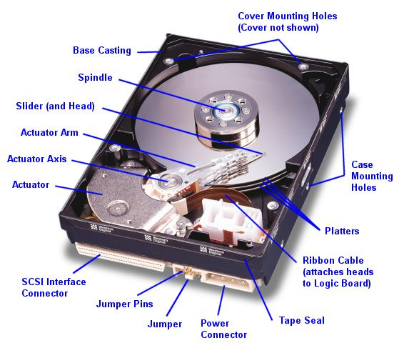
Figure One – Internal components of a SCSI HDD.

1.1 Data recorded on the HDD is written as tracks. The tracks consist of magnetised information located in different directions (bits) along the track. Magnetisation of the media plane, results in a signal being detected as a change in the out phase component of the magnetic field. This form of storage, known as longitudinal recording, is the traditional and most widely used.

An alternative scheme known as perpendicular recording exists where media is magnetised out of plane of the film. This method has several advantages the main ones being the magnitude of the fields generated in the scheme are larger than in longitudinal recording allowing for easier signal detection. Additionally, magnetic signal density is significantly higher than longitudinal recording, increasing storage capacity.

Normally, a file is stored to a series of sectors on the same or an adjacent track (providing faster means of access and performance). In order to find the correct piece of information, the drive must take the logical block address (LBA), which is the address the operating system (OS) uses to specify the data, and translate that to a physical address on the HDD.

Figure 2 outlines how data is recorded in a series of concentric rings on the platter known as tracks. Tracks are broken up into sectors, with sectors normally containing 512 bytes of data.

Translation is performed by the HDD using a translation map which defines platter, track and sector.

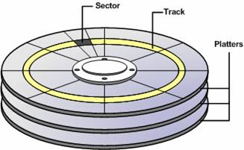

Figure Two – Sectors and tracks of a HDD platter

Instead of using absolute positioning (i.e. where the position of a sector is defined to a specific location on the HDD); modern drives use a servo system where regular bursts of information, stored on the disk surface, inform the HDD of its present position. During HDD manufacture, servo wedges are embedded onto the platters which aid alignment of the heads with a track whilst defining which track is currently under the read head.

Areal density is the storage capacity of a HDD. Usually measured in gigabytes per square inch, a variety of techniques are employed on modern HDD to increase the areal density which includes:

- Reduce inter-sector and inter-track gaps allowing for more ‘dead space’ to be used.

- Remove the ID at the start of each sector and store the data in RAM allowing for average access rates to be increased.

- Perpendicular recording allows for ever smaller magnetic grains.

There is a physical limit on how small magnetic grains can become before they are affected by thermal changes. Small magnet grains may have their magnetic polarisation changed (i.e. a 1 bit may change to a 0 bit) thereby causing data loss. This is referred to as the Super Paramagnetic Effect (SPE) defined by Mueller (2009) as “the point at which magnetic domains become so small they become unstable at room temperature”. Perpendicular recording means magnetic grains do not need to be so small they become affected by SPE allowing for very high areal density.

Despite strict control over the manufacturing process, it is impossible for vendors to produce a HDD without defects. To balance this problem, vendors produce HDD with a number of spare sectors.
During manufacture the HDD identifies defects on the platter surface and tag it as being unusable with the location recorded in the primary list of defects (P-List). During formatting, the LBA is allocated with the drive ignoring the physical sectors in the P-List with the next available sector allocated the next available LBA.

HDD also contain a G-List – a list defective sectors which have “Grown” since factory formatting. As the HDD operates it notes any sectors which cannot be read or written too correctly. These errors may be down to a complete failure to read or write data; or a relatively large number of re-reads required to correctly read the data. Either way these bad sectors are added to the G-List and the next available sector is allocated to that LBA.

This remapping is invisible to the OS since bad sectors are identified by the drive itself and mapped out during normal operation. Both P and G-Lists are stored as tables on the HDD which can be accessed or modified using specialised low-level AT Attachment (ATA) commands.

Two common techniques exist for detecting data during the read process. The first of these is Peak Detection (PD) in which the system attempts to detect if there was a transition in the form of a peak of a certain given value. The second method is Partial Response Maximum Likelihood (PRML) during which the detection circuit looks at the overall shape of the response and attempts to determine the most likely bit pattern to give that response. PMRL is also defined by Haeusser, Dimmer et al (2007) as “magnetic fluxes sampled to logic algorithms which reconstruct the data stream”.

At relatively low recording densities the voltage pulse from each transition is isolated from one another and PD detection techniques work well. As the density of recorded information increases, the pulse from each transition start to overlap and interfere; PRML understands nearby transitions will interfere with each other.

1.2 Data loss whilst attributed to a number of reasons can be broadly categorised into five probable causes:

- Hardware failure within the HDD.

- Human intervention, accidental or malicious.

- Malfunction due to malicious software.

- External disaster which physically damages the disk.

- Software malfunction corrupting the File System (FS).

Software recovery techniques can be employed where the HDD still functions. Hardware based recovery is also possible where the aim is to get the drive functioning followed by data extraction.

Additionally, advanced recovery techniques may also be employed where the focus is on imaging the data pattern on the platter surface then extracting data from the encoded pattern.

Software based recovery is often carried out on working drives where loss of data is related to either deletion, corruption or some change in the file allocation system.

OS recovery tools (i.e. system restore disk) allow the novice to recover data, additionally commercial software such as On-Track supplied by http://ontrackdatarecovery.co.uk/software have since Jan 2008 been accredited with Communications Electronic Support Group (CESG) highest standard on specific hardware platforms and OS. CESG are the UK National Technical Authority for Information assurance.

If the HDD fails to function (i.e. not spin-able) hardware based recovery will be necessary.

Part Swapping recovers data from a drive suffering mechanical or electrical failure. The use of an equivalent drive to the to the faulty one – including manufacturer, date of manufacture, model serial number, Printed Circuit Board (PCB) are close a match as possible. Other techniques used are:

- Remount platters into a replacement drive.

- Hot swapping – where the boot sector is defective, an attempt is made to boot the PCB on a similar working drive so it can read boot information into RAM before swapping the PCB back to the failed drive. If the HDD becomes functional, a low level image is taken.

Accessing the drive at a base level allows for numerous factors to be varied. The number of reads or retries the drive will make when trying to read a track or sector significantly increases the likelihood of data recovery at the cost of longer read times.

Hardware based techniques can recover most data providing platter surfaces have not been damaged or sectors overwritten, although even with a slightly damaged platter surface, multiple re-reads of the surface may allow data extraction. Conversely, significant damage to the platter makes it almost impossible to recover data via the read/write heads.

The basis for advanced data recovery is that where it is possible to see data patterns on the platter in magnetic form and if nothing is done to remove these patterns, theoretically it is possible to use a technique which observes the bit pattern and reconstruct the data. The recovery is conducted in two parts, firstly recovering the data pattern and secondly extracting the data from this pattern. Pattern recovery methods are twofold:

Magnetic Force Microscopy (MFM)

In MFM, a magnetised tip is scanned over the surface of the platter to obtain an image of the magnetic domain structure containing the recorded bits. It is also possible to image sidetracks and observe remnant data. Use of this technique allows for data to be imaged on the platter or a platter fragment. Physical damage to the platter rendering conventional read/write heads useless is not a problem with MFM however the main disadvantage is the very slow data recovery rate. Long time durations and vast amounts of data storage capacity are needed for viable MFM data recovery. Buschow (2005) describes MFM as “a slow scan imaging techniques which maps a signal issued from the interaction of a tiny magnetic probe or tip”.

Spin Stand Imaging (SSI)

SSI is comparable in form and duration to the HDD read process. A very sensitive read/write head attached to the actuator arm moves across the head over the platter surface, mounted on a spindle. The spindle is rotated and the head assembly scanned over any part of the platter to access the magnetic data patterns. This technique uses the smallest and most sensitive read/write heads it is possible to produce the highest resolution images. Although SSI does not have the data recovery rate problems of MFM imaging, it does require a relatively intact platter that can be spun at very low speed.

Once the image of the data pattern has been recovered the next step is to decode the response function from the spin stand or MFM into tester data (i.e. data extraction). This can be performed in one of three ways:

- Feed the response function into a similar set of HDD and use to decode the data.

- Reverse engineer the encoding process – allowing greater flexibility and further optimisation.

- Cryptographic-like brute force attacks could be employed. Since there are only certain allowable encoding processes, each one is tried until an output is obtained.

1.3 Based on damage to the drive, HDD sanitisation can be broadly divided into 4 categories:

- Platter destruction – where the platter or information stored in the magnetic layers is significantly damaged.

- Spin able disk – where the drive is unusable but the platters can be spun up to an operational speed.

- Un-spin able disk – where the platter is slightly damaged and cannot be remounted or spun to an operational speed.

- Overwriting – where the drive remains undamaged and reusable.

If the platter is subjected to a destructive force, data recovery is significantly reduced even when employing advanced recovery techniques. Usual destruction processes include:

- Incineration – where the magnetic recording surface is heated above the Curie temperature (i.e. where it loses all its magnetic properties).

- Disintegration – reducing platters to a minimal size.

- Degaussing – where the magnetic material is subjected to a powerful magnetic field such that no magnetic information remains.

The latter eradicates not only data, but also the timing and synchronisation information embedded into the platter, making the drive completely unusable.

HDD with a damaged case, but platters are spin able, may not be entirely damaged. Data recovery can be achieved, normally by commercial organisations, using software and hardware recovery techniques with a high probability of success. Spin stand processes can be used if standard recovery processes cannot recover the data.

If the disk cannot be spun, standard hardware recovery is likely to be beyond the resources and capability of most organisations. Successful data recovery from non-spin able disks is possible by advanced recovery and where organisations have the motivation, time, funding and expertise to viably recover sanitised data.

Overwriting existing data with different information can be divided into 3 different levels:

- At the lowest level, a very quick and simple process is to write binary zeros over the Master Boot Record (MBR), volume records and allocation system. Equivalent to, although more effective than formatting the drive. Data is still present and can be recovered by scanning the disk.

- At the intermediate level, a more complete scheme is employed in which binary zeros are written to every accessible sector on the drive. Equivalent to low level formatting, it is possible that overwritten data is still recoverable (i.e. side tracks and data remanence).

- At the highest level, multi-pass overwriting is performed and verified in accordance, where either a single or triple over-write pass plus a verification pass are used.

1.4 Personal computer HDD are broadly categorised into 2 main families. Integrated Drive Electronics (IDE); now superseded by AT Attachment (ATA) and Small Computer System Interface (SCSI).

Within the 2 families, different variants exist which specify alternative physical connectivity options implemented by the device, although command instruction sets are common.

- IDE/ATA: including Parallel ATA (PATA) and Serial ATA (SATA)
The majority of personal computers have support for either PATA or SATA devices using host controllers built into the motherboard. However, SATA devices may require hardware specific drivers to allow overwrite applications to access drives connected to the host controller.

For hardware compatibility information, the manufacturer’s technical information should be used.

- SCSI: include SCSI1, SCSI2, SCSI3, Low Voltage Differential (LVD), SCSI (Ultra2), (Ultra3), (Ultra 160), (Ultra 640), (Fast 320), SCSI Fibre Channel Protocol (FCP).

In order to support SCSI devices, host bus adapter (HBA) expansion cards are usually added to the system, as shown in Figure 3, alternatively motherboards with specific SCSI support are used. Produced by a variety of manufacturers it may be necessary to determine specific drivers which allow overwrite applications to access drives. For hardware compatibility information, the manufacturer’s technical information should be used.

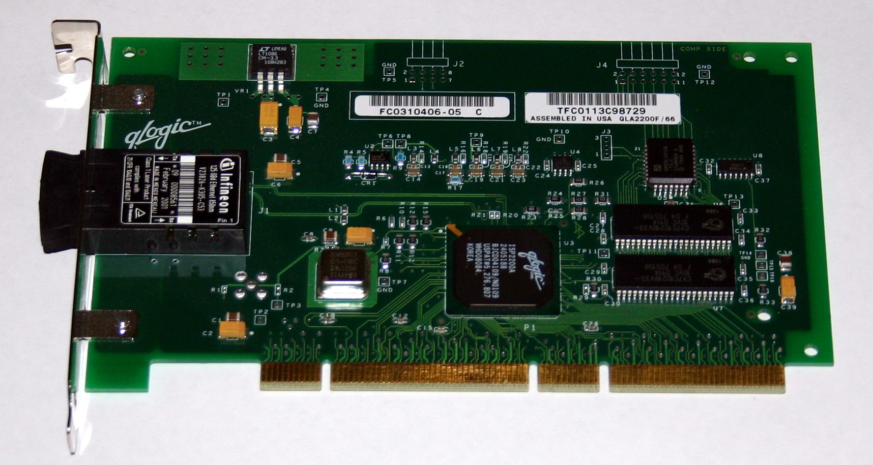

Figure Three: QLA 2200 Fibre Channel Host Bus Adapter

1.5 There are many types of tape storage media used for recording and storage tasks (i.e. audio recording audio, video playback and data archiving). This section compares the main types of magnetic storage tape media for audio and video.

Although audio and video magnetic tapes use differing formats they are formatted during the “write” process, meaning tapes may be bulk erased (i.e. degaussed) and reused.

The two main families of tape media are Digital Linear Tape (DLT – including Super DLT), and Linear Tape Open (LTO) Ultrium.

Capable of storing between 10 to 40 GB of uncompressed data, DLT is the industry standard format for midrange computing backup and archive applications gaining prominence by being the only format capable of matching Moore’s law – “meeting the doubling of capacity needs every 18 months”. DLT technology is backward compatible between successive generations of tape drives, with half inch variants having a planned storage life of 30 years.

Super DLT is the next generation platform and the industry standard for midrange UNIX and Windows OS system backup and archive applications. Super DLT technology is based on Laser Guided Magnetic Recording (LGMR) technology using optical and magnetic technology to increase the number of recording tracks on the media surface.
According to Mueller (2006), LGMR “uses a pivoting optical servo on the backside end of the media with a thin film magneto resistive cluster head for tape reading and writing allowing for higher efficiency and greater recording density”; a point illustrated in Figure 4.

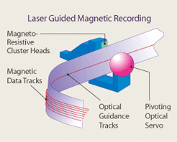

Figure 4 – the Pivoting Optical Servo (POS) used within LGMR

The storage capacity of Super DLT ranges from 110 to 320 GB depending on compression usage.

Since the DLT and Super DLT tapes use optical tracking, bulk erasing does not affect the tracking information, therefore DLT and Super DLT can be reused unlike LTO Ultrium which is unusable after degaussing.

LTO Ultrium developed as a competitor to DLT, stores data in 384 tracks divided into four bands of 96 tracks. Servo information, written at the time of manufacture; border the four bands with each data bands filled one at a time, in a linear fashion. Each servo band keeps the read/write head precisely aligned with the data bands with the magnetic servo tracks on encoded by the vendor.

1.6 HDD consists of a series of platters, magnetic flat surfaces coated rotating on a single spindle. Each platter encompasses a series of concentric rings upon which both tracks and sectors with storage capacity, or areal density is normally measured in gigabytes.

SPE, PD and PMRL all contribute to the read/write ability of a HDD. HDD advanced recovery techniques include Magnetic Force Microscopy and Spin Stand Imaging. Data recovery on HDD subjected to destructive force is significantly reduced even when employing advanced recovery techniques, ergo incineration, disintegration and degaussing and the normal destruction processes.

Personal computer HDD can be broadly categorised into 2 main families; IDE/ATA and SCSI with the latter supporting HBA expansion cards.

The two main families of tape media are DLT – including Super DLT, and LTO Ultrium, capable of storing in excess of 320GB.

Chapter Two – Sanitisation of Magnetic Media:

2.0 Overwriting is the industry recognised mechanism for sanitisation of a HDD and is defined as the process of replacing data with random data so that recovery is not possible.

2.1 Data written to a magnetic media using binary ones and zeros is read back and interpreted as 8 bits (byte). If the data is properly overwritten (i.e. 11111111 followed by 00000000) the magnetic fluxes are changed ensuring only the new pattern is detected. To that end, the following should be observed:

- Low Level overwriting is defined as a single overwrite with any octet followed by a verification pass. Sanitisation is not achieved until both overwrite and verification passes are correctly completed.

- High Level overwriting requires overwriting with a binary value (octet), its complement and finally another octet (i.e. over-write first with “00110101” followed by “11001010” then “10010111”), with a verification pass confirming the success of the overwrite.

Overwriting software specifications are the minimum conditions which must be applied to overwriting a HDD. Software should be verified as being compatible with the particular disk being sanitised. To ensure the integrity of the sanitisation process, software should include:

- The ability to purge all data or information, making it impossible to recover any meaningful data through the keyboard.

- Compatible or capable of running independent of the OS.

- Compatible or capable of running independent of the HDD.

- Capable of overwriting the entire HDD independent of any BIOS or firmware.

- Verification all data has been removed and the ability of viewing the overwrite octet.

- Provide a validation certificate indicating the overwriting procedure was completed.

- Provide a defects log, or list of any bad sectors not overwritten. The HDD should only be considered sanitised if the actual and reported addressable areas are the same.

HDD platters may develop damaged or unstable tracks or sectors however sensitive data may have already been recorded in areas of the disk. If features or malfunctions of the HDD inhibit overwriting, the HDD should be degaussed or destroyed.

2.2 CHS and LBA are addressing methods used to access HDD. In determining the capacity of a disk it is important to understand the basics of these addressing methods:

The CHS addressing method utilises the number of cylinders, heads and sectors per track specified for a given disk. Even though this method is now obsolete for modern hard disks it may still be seen on some devices.

The LBA addressing method uses a linear mapping of sectors. The first sector on a disk is LBA0 continuing incrementally. Typically if the ATA device is greater than 7.8GB (assuming a 512 byte sector), LBA is used.

2.3 As the capacity of the HDD has increased, so have the number of possible addressable sectors. An ATA drive using LBA was restricted to a 28bit address value limiting the maximum address range to 268,435,456 sectors or 2^28 (assuming a 512 byte sector size).

To overcome this, the LBA address range has been increased to a 48bit value expanding the maximum address range to 281,474,976,710,656 sectors or 2^48 (assuming a 512 byte sector size).
2.4 SATA whilst being a relatively new ATA interface specification shares the same command instruction set as the PATA devices; however it uses a different hardware connector. Developed to permit greater data transfer rates than PATA, SATA utilises 28bit/48bit LBA depending upon the capacity of the device.

2.5 RAID is a method by which data is shared or replicated over multiple devices, increasing data storage reliability, improving fault tolerance and integrity. In addition, greater data throughput and capacity may be achieved when compared to single disk. RAID can be accomplished utilising either dedicated hardware controllers or a software based implementation. RAID can be implemented using any variants of both IDE/ATA and SCSI disk devices ergo the following should be noted:

- Overwriting a software RAID requires no special action in addition to that used for single disk overwriting. The only issue is the number of HDD within the physical system. In order to identify the exact number of disks housed within the system, an internal inspection to determine the quantity, make, model and capacity of disks may be required.

- Overwriting a hardware RAID will require an internal inspection to determine the quantity, make, model and capacity of disks incorporated within the system. The removal of individual devices for overwriting may be necessary but this is dependant upon the overwrite application being able to ‘break’ the RAID and correctly report each individual device within the system. The ability of the overwrite application to accomplish this is dependant upon support for the specific hardware RAID controller installed in the system.

2.6 Fibre Channel disks are another variant of SCSI. Disks having a fibre channel interface usually implement SCSI commands requiring a HBA interface installed on the host system.

- In order to overwrite a Fibre Channel disk the overwrite application must support the HBA installed in the system.

2.7 The overwrite application of a media device is required to perform a trusted boot. That is, to boot the computer in such a way that malicious code cannot be executed. To date the acceptable way of achieving this has been through the use of a known good write protected floppy disk or non-rewriteable CD or DVD-ROM.

This is analogous to shrink wrapped software and the inherent trust placed in the application and packaging. More recently it is common that computer systems do not have floppy disk drives installed, and possibly no CD-ROM. In such cases an alternative overwrite application delivery methods is required, therefore:

- Overwrite applications used from a non-trusted source should contain embedded within a mechanism of self verification in order to assure the integrity of the application before commencement. Additionally it should alert the tester if the integrity verification fails.

It may be necessary to boot the system over a network to load the overwrite application. This should not be performed on a production system using instead a separate network to assure the system to be overwritten connects only to the boot server. Additionally,

- Overwrite application should be able to verify the integrity before overwrite commences. The application should be able to communicate with the server in order that integrity check failure or completion is reported.

Memory Sticks or USB devices are now in common use for data transfer between computers taken over the role of the floppy disk; typically connecting to a system via a USB port. In order for a system to boot from a USB port, support for booting from this interface is required from the system BIOS.

To use this type of delivery method the memory stick should be prepared in the following way:

- Clear the device.

- Load a bootable OS from a known good source (i.e. DOS).

- Load the application from the known good source.

2.8 An increase in devices which include embedded HDD for temporary storage of information, such as printers, photocopiers, fax machines or multifunction devices are used to process commercially sensitive and personal information, which in turn may inherit the attributes of the information. These devices also have embedded within their firmware functionality to erase the HDD.

Should equipment of this nature require overwriting due to service repair, maintenance, or replacement the embedded firmware should have the following capability:

- Verify the overwrite integrity prior to commencement.

- Embedded media must be initiated prior to overwrite.

- Produce a report detailing the full make, model, serial number and capacity of the embedded HDD. The report should include the type of overwrite and confirmation it has completed successfully.

2.9 The Secure Erase (SE) command is part of the open American National Standards Institute (ANSI) standard which controls ATA interface and SCSI specification.

SE is built into the HDD electronics, implemented in all ATA interfaces manufactured after 2001. Additionally, a standardised internal SE command also exists for SCSI drives; however this is not widely supported.

Executing the SE command causes a drive to completely overwrite all data, including G-List records that may contain readable data in re-allocated disk sectors (i.e. sectors no longer used by the drive since they have hard errors).

SE is an addition to the existing “format drive” command present within the OS and storage system software. Since the SE command is carried out within the HDD and SE performs a single on-track erasure of data on the HDD, no additional software is required.

2.10 HDD are being launched with two and half inch drives (i.e. laptops) using full data encryption. Such drives provide protection should the laptop be lost or stolen, and provide high protection from forensic data recovery. Encrypted drives also offer a new instantaneous way to sanitise data on the HDD by securely erasing the encryption key.

Full Disk Encryption (FDE) Enhanced Secure Erase (FDESE), securely changes the internal drive encryption key to render the encrypted data on the HDD indecipherable; this is enabled via the Enhanced SE command. For complete security the encrypted data on an FDE drive could be erased by normal SE over-write following the FDESE. FDESE offers the possibility of emergency sanitisation as FDESE takes only a few milliseconds to compete.

2.11 The process of degaussing is achieved by passing magnetic media through a powerful magnetic field, completely removing any of previously recorded signals and may be accomplished in two ways:

- AC erasure, the media is degaussed by applying an alternating field reducing in amplitude over time from an initial high value.

- DC erasure, the media is saturated by use of a permanent magnetic field.

2.12 Degaussing HDD often destroys the drive’s timing tracks and servo motors, and usually demagnetises the spindle motor. Hence HDD are unusable after being degaussed. The traditional method of recording magnetic signals on a HDD is in the same plane as the disk (longitudal). Very high data storage capacities on modern HDD have seen many developments in recording techniques including perpendicular where the magnetic signals are recorded at 900 to the plane of the HDD; therefore degaussing equipment should be capable of degaussing either of the recording orientations.

2.13 Degaussing equipment may be designed to sanitise either tape or HDD with vendors offering many types. The design of the degaussing equipment will determine how the media should be placed into the degausser ensuring effective sanitisation. Degausser types and operating methods are usually:

- Drawer Type – electromagnetic degausser providing an automatic single pass operation for the erasure of tape storage media as well as being capable of sanitising three and a half inch HDD or smaller. Media must degaussed on either side, with all casings or mounting brackets removed beforehand and the degausser operated at its maximum magnetic field strength:

- Conveyor Type – electromagnetic degausser operating via a continuous conveyor belt providing one pass erasure for tape storage devices.

- Chamber Type – electromagnetic degausser providing automatic single pass operation for the erasure of tape storage device.

- Hand (Wand) – permanent magnet degausser to degauss HDD storage media. Each active disk surface (top and bottom) should be wiped at least three times. Disks which are part of a sealed HDD assembly should be removed from the assembly for effective degaussing.

- Single Pass Slot – enclosed permanent magnetic degausser requiring one pass for effective erasure.

- Dual Pass Slot – enclosed permanent magnet degausser in which the disk is passed through the entry slot and degaussed with the disk rotated 900 times and passed through the slot a second time.

2.14 Overwriting is the industry recognised mechanism for sanitisation of a HDD, normally by the HDD being written to with a combination of 1’s and 0’s with appropriate and compatible software.

CHS and LBA are addressing methods used to access HDD in order to determine its capacity.

RAID (either software or hardware) is a method by which data is shared or replicated over multiple devices for improved reliability, fault tolerance and increase data capacity. Over writing a software RAID requires no special action other than to carry out an internal inspection of the system; identifying the exact number of disks in use. Over writing a hardware RAID also requires an internal inspection as well as ensuring the overwrite software has the ability to ‘break’ the RAID correctly.

Fibre Channel disks, providing they have a HBA interface function similar to a SCSI although overwriting software must be compatible with both.

The SE command causes a HDD to completely overwrite all data, including G-List records, therefore no additional software is required.

Degaussing normally destroys the HDD timing tracks, servo motors, and demagnetises the spindle motor. However, degaussing equipment should be capable of degaussing either of the orientations.
Chapter Three – Sanitisation of Solid State Devices:

3.0 This section examines data remanence issues within volatile and non-volatile semiconductor memory concentrating on Static RAM (SRAM), Dynamic RAM (DRAM), electrically erasable (EEPROM) and Universal Serial Bus (USB) flash memory devices.

Semiconductor or volatile memory is defined as memory where content is expected to be lost when the power is removed.

Non-volatile data, where a separate power supply (i.e. battery or capacitor) is used, ensures memory content is maintained after the power supply is removed. Power may be considered removed if all power sources, including built-in power supplies are removed and the voltage across all terminals of the semi-conductor memory devices is less than 0.05 Volt.

Due to the potential presence of capacitances, this usually requires terminals be shorted together; using a suitable resistor for safety until the voltage has fallen below the specified voltage. Memory effects in capacitors require this connection be maintained for a finite period of time.

BIOS memory in old computers cannot be altered, or cannot be altered without unplugging or removing the memory chip(s) therefore such memory cannot be contaminated by software from within the computer. However, BIOS memory in new systems is susceptible to being subverted covertly; therefore organisations may wish to implement sufficient physical controls (i.e. BIOS password) to mitigate this risk.

Personal Digital Assistants (PDA) retain many of the security problems of BIOS memory in that these devices have nominally read-only memory that may be used to store initialisation software or the OS. If the protection afforded to the nominally read-only memory is sufficient, organisations may decide that such memory does not contain sensitive information.

Some PDA software has been approved as providing confidentiality by the use of cryptography against the threat of accidental loss or theft. Where a PDA has been used with such software, organisations may decide it would be reasonable to assume the software continues to provide protection when the PDA is disposed of at the end of life, particularly if the PDA memory is cleared.

Some solid state disks are supplied with built-in encryption. Providing the organisation has accepted the cryptography is fit for the purpose, the data itself need not be purged or cleared although the location where the crypto key variable (KV) is stored should be treated as containing possible sensitive data.

Open source literature describes how it is possible in some cases to add connection pads to chips even after the normal connections have been physically destroyed (i.e. by etching a small hole in a power connecting plane on a chip and depositing a new connection to the inside of the chip).

3.1 SRAM memory cells typically consist of cross coupled inverters based on Field Effect Transistor (FET) technology. Swaaminathan, Engin (2007) define FET as “multi-terminal switches that are turned on or off on the basis of a control signal. In a CMOS FET two types of transistors are used; n-channel and p-channel” – illustrated in Figure 5.

Data is stored in a SRAM cell by setting the condition of a bi-stable electrical circuit capable of remaining in a given state as long as power is applied and no new data is written. SRAM has faster access times and lower power consumption than DRAM however it only has about 25 percent of the packing density due to their more complex circuitry.

SRAM is susceptible to retaining data. If the same information is stored in the same location over a sustained period of time, SRAM has the ability to ‘shadow’ or ‘remember’ previously held information, or state for several days even when power has been removed.

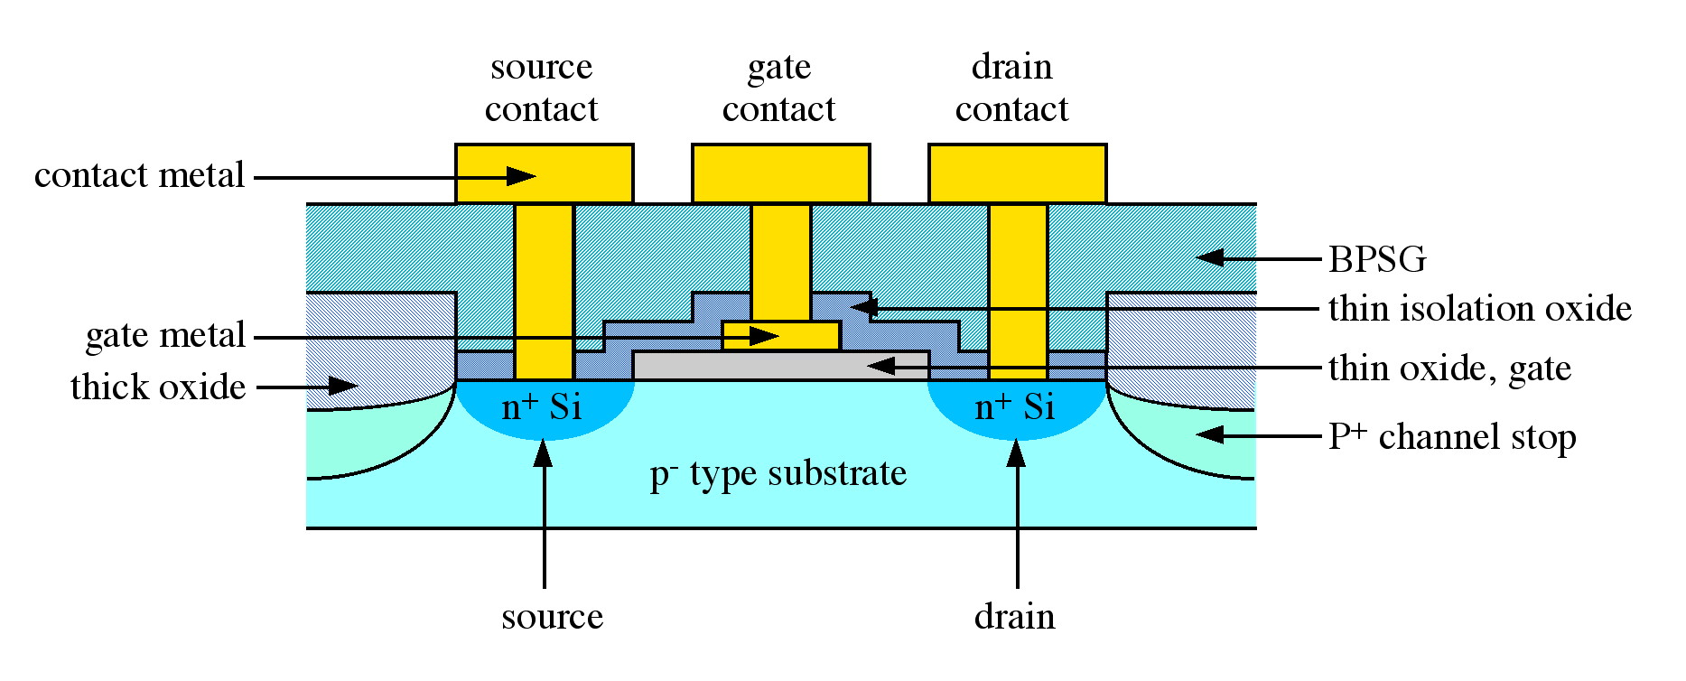
Figure 5 – Cross section of a CMOS FET showing n-channel and p-channel.

3.2 DRAM memory performs the functions of a capacitor and transistors used to read, write and refresh charge in the capacitor at periodic intervals.

3.3 EEPROM/Flash memory is now present in many electronic items including answering machines, cameras, fax machines, mobile phones, PDAs, photocopiers and transportable devices such as USB disks. Some computers designed for use in high vibration scenarios use EEPROM/Flash Memory disks in place of the more conventional magnetic hard disks.

Such memory devices are particularly problematic to purge as they contain a powerful microcomputer running firmware often unevaluated from a security stand point. Typically when such devices are required to write data to a cleared location of memory, they make a number of low energy write cycles and then read the data back. Depending on the voltage read back, the device performs more write cycles until either a satisfactory noise margin has been obtained or a write limit has been reached.

If the write limit has been reached, built-in firmware will note the section of the memory used is faulty or unreliable and use a different section of the available memory.

A side effect is that if the memory chip is read directly, it is possible, without using any complex chip probing technology, to read the block of data that could not be reliably written. Indeed, the firmware in some devices provide diagnostic facilities allowing the faulty memory to be read without even removing it from its housing; in such cases, the only tool needed to recover data is the maker’s diagnostic software.

When memory has been marked as unusable, the memory left for use decreases. Two common solutions to this problem are:

- Allocate spare blocks of memory as and when required. One disadvantage of this technique is that no warning is given of the number of blocks that have failed.

- Decrease the apparent size of the memory as declared to the higher level functions.

Firmware in some USB memory sticks may not always comply with the USB convention. For example, firmware may declare the same serial number and product number in devices with very different capacities; however it is possible two memory sticks with the same asserted model number, manufacturer and serial number contain differing memory chips; altering the purging perspective.

Low price and low quality control mean these serial numbers may not be changed even when the firmware in the memory device has been significantly changed. Solid state devices use wear levelling techniques to increase the life of the memory, by minimising the number of times a particular part of the memory is used. The operation of wear levelling acts to produce a worst case situation, in which if a file is created and overwritten 10 – 100 times, several copies of the data is written to different storage locations, followed by the actual data being written to a fresh location.

Dependent on the firmware, the device may clear old copies of the data when new copies are added, however this effect may be negated from the security point of view by the way the OS manages its file systems, therefore even the act of creating a file and apparently overwriting is not easily performed as drivers will often allocate a new part of the disk to store the file.

It is possible to demonstrate that all files have been deleted and recover the files intact simply by restoring a few pointers in the director whilst in the case of FAT 16 devices, simply changing a single byte will often recover. Formatting the USB disk make this trivial attack impossible, as will any method that genuinely overwrites the disk at the OS level. However, for speed, many USB devices merely report that the device has been formatted, and not actually over-write the contents of the chip memory. It is impossible to generalise as different makers use different drivers, a fact that is concealed by XP which automatically selects the correct driver for the make of memory stick.

3.4 Even writing sufficient data to cycle through all storage locations may not suffice since pseudorandom storage location selection techniques can result in some memory locations being overwritten many times and others only a few. To that end,

- Cryptographic Key Variables (KV) should not be retained for long periods without the original storage location being zeroed or bits inverted.

- Non-volatile memory should ideally be filled up to 100 times with nominally random data before writing thereby negating the effects from freshly used cells.

- Data held in volatile memory for prolonged periods cannot be presumed to have been erased when the volatile memory is cleared. Hot carrier and electro-migration effects in cryptographic devices could retain an image long after the original has leaked into the substrate.

Chapter Four – Sanitisation of Optical Media

4.0 Relatively inexpensive, optical media (i.e. CD/CD(RW) and DVD/DVD(RW)) is one of the most widely used forms of storage for audio, visual and general data.

4.1 During the recording process, a laser heats selective areas of the recording track above melting point, normally 500 - 700 degrees Celsius, additionally for CD-RW writing the laser range is between 8 - 14milliwatts. Pulsed energy delivered by the laser melts the crystals in the heated areas to a non-crystalline amorphous phase known as ‘pits’ as opposed the lower reflective areas known as ‘lands’ – as shown in Figure 6.. The difference in reflectance allows for recorded data to be readout producing a signal similar to that of a standard CD.

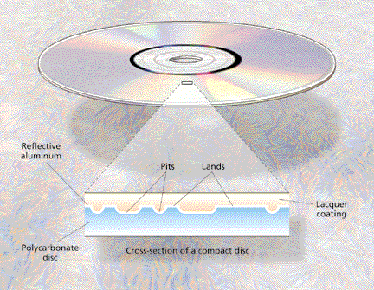

Figure 6 – Cross section of a CD detailing Pits and Lands.

4.2 Erasure of a CD-RW disk is performed by returning the recording layer from an amorphous state back to a crystalline state. This is done by an annealing process, heating the layer to a temperature to about 200 degrees Celsius (i.e. less than the melting point). The disk is then returned to its original, completely unrecorded state.

The overwrite process is achieved by using both techniques. New pits are written using the same laser technique; however new crystalline areas are written to areas between the pits at a lower energy resulting complete erasure.

4.3 Optical media is relatively inexpensive and in most circumstances the media will be sanitised by physical destruction (usually disintegration or incineration). However, where reuse of optical media is required, the above process should be used.

Chapter Five – Disposal of Printers, Copiers and Multi-Functional Devices

5.0 Digital photocopiers and Multi-Function Devices (MFD) often have combined copy, print, scan and fax functionality presenting additional security considerations given that they share much of their technology with computers.

5.1 Copiers and MFD operate by scanning to an onboard electronic memory before printing. Of particular concern is the risk that images maybe retained by the copier or MFD HDD or in the electronic memory before printing. Copiers and MFD have additional risk in that maintenance or service support staff may need to connect a laptop or other diagnostic devices to it, which in turn create an opportunity for data to be transferred or copied to any network to which the copier and MFD are connected. Vendors may incorporate erasure and encryption to protect data however, these measures may not have been evaluated or approved nor can they be validated by an organisation.

5.2 To minimise the risk of compromise of data stored on these devices, the following controls should be considered:

- Document risk assessments of security, technical and support issues.

- Liaise with vendors to establish:

- Fault reporting process and procedures.

- Authorisation procedures prior to maintenance staff accessing the device.

- Controls for components introduced by maintenance staff.

- Procedures preventing remote access for maintenance, support or updating.

- Sanitisation procedures for components, in particular electrostatic drums, hard disks and memory components.

- Purchase and maintain a diagnostic laptop for use by maintenance staff.

- Ensure HDD and memory removal is preventable.

- HDD which need replacing should be purged, destroyed by the organisation.

5.3 Several manufacturers offer additional products including erasure and encryption functionality which has been evaluated both by industry and government; these products should be used wherever possible. Additionally, copiers and MFD should be sited in supervised environments or where access controls can be placed to prevent unauthorised use. Furthermore, photocopying equipment should be locked or disabled with keys securely locked.

5.4 Using the factors listed above, an organisation should determine the appropriate level of disposition (i.e. clear, purge or destroy) with an appropriate sanitisation method determined.

Chapter 6 – Disposal of Networked Equipment

6.0 Networking equipment such as routers and switches use a number of different data storage devices. Specifically, RAM is used to store dynamic routing tables and configuration information, with packet data also held temporarily whilst headers are analysed for routing options. Furthermore, given that the router OS is stored within flash memory, networking equipment incorporates non-volatile solid state device storage (NVRAM) which stores the configuration in the event of a power failure. Note network routers may also have magnetic HDD storage capability.

6.1 Due to the variety of storage media used in networking devices, disposal or decommissioning is largely dependent on several factors such as:

- Deployment of the networked equipment (i.e. is re-deployed within the same organisation?).

- Does the new network architecture resemble the old architecture (i.e. is IP address re-use an option?).

- If equipment is being reused, consideration on how the router caches and flushes RAM should be factored since cache contents will consist of packet header and data.

- Internal flash memory should be removed and destroyed.

- If networking equipment is to be redeployed within same organisation consideration of whether the router names and passwords are to be changed.

- Manufacturer procedures for resetting the device to its factory settings should be retained.

6.2 Using the factors listed above, an organisation should determine the appropriate level of disposition (i.e. clear, purge or destroy) with an appropriate sanitisation method determined.

Conclusions and Recommendations:

Procedures should documented and implemented for media earmarked for re-use, disposal, repair, exchange or recycled with appropriate controls implemented regarding handling, labelling, storage, clearing and physical destruction.

Sanitised media should be subjected to similar controls pertaining to clearing; reuse or degaussing with verification reports generated confirming the success of the sanitisation process.

Peak Detection and Partial Response Maximum Likelihood are two techniques for detecting data during the read process.

Software recovery techniques can be employed where the HDD still functions, or where the loss of data is related to either deletion, corruption or some change in the file allocation system.

Hardware and advanced recovery techniques may also be employed where the focus is on imaging the data pattern on the platter surface then extracting data from the encoded pattern.

Theoretically it is possible to use a technique which observes the bit pattern and reconstruct the data, known as Magnetic Force Microscopy and Spin Stand Imaging.

Based on damage to the drive, HDD sanitisation can be broadly divided into 4 categories;

- Platter destruction

- Spin able Disk

- Un-Spin able disk

- Overwriting

The two main families of tape media are Digital Linear Tape and Linear Tape Open.

To ensure the integrity, software sanitisation should include:

- The ability to purge all data or information, making it impossible to recover any meaningful data through the keyboard.

- Compatible or capable of running independent of the OS.

- Compatible or capable of running independent of the HDD.

- Capable of overwriting the entire HDD independent of any BIOS or firmware.

- Verification all data has been removed and the ability of viewing the overwrite octet.

- Provide a validation certificate indicating the overwriting procedure was completed.

- Provide a defects log, or list of any bad sectors not overwritten. The HDD should only be considered sanitised if the actual and reported addressable areas are the same.

Overwriting a software RAID requires no special action in addition to that used for single disk overwriting. Overwriting a hardware RAID will require an internal inspection to determine the quantity, make, model and capacity of disks incorporated within the system.

Overwrite applications used from a non-trusted source should contain embedded within a mechanism of self verification in order to assure the integrity of the application before commencement.
Use of a separate network is required to assure the system to be overwritten connects only to the boot server.

MFD equipment should have the ability to:

- Verify the overwrite integrity.

- Embedded media must be initiated prior to overwrite.

- Produce a report detailing the full make, model, serial number and capacity of the embedded HDD.

For complete security the encrypted data on an FDE drive could be erased by normal SE over-write following the FDESE offering the possibility of emergency sanitisation.

Non-volatile data, where a separate power supply (i.e. battery or capacitor) is used, ensures memory content is maintained after the power supply is removed or less than 0.05v.

Key Variables should not be retained for long periods without the original storage location being zeroed or bits inverted.

Non-volatile memory should ideally be filled up to 100 times with nominally random data before writing thereby negating the effects from freshly used cells.

To minimise the risk of compromise of data stored on these devices, the following controls should be considered:

- Document risk assessments of security, technical and support issues.

- Liaise with vendors to establish:

- Fault reporting process and procedures.

- Authorisation procedures prior to maintenance staff accessing the device.

- Controls for components introduced by maintenance staff.

- Procedures preventing remote access for maintenance, support or updating.

- Sanitisation procedures for components, in particular electrostatic drums, hard disks and memory components.

Manufacturers which offer ‘security kits’ should be used wherever possible.

Disposal or decommissioning of networking devices depends on several factors such as:

- Is re-deployment within the same organisation an option?

- If equipment is being reused, consideration on how the router caches and flushes RAM should be factored since cache contents will consist of packet header and data.

- Internal flash memory should be removed and destroyed.

- If networking equipment is to be redeployed within same organisation consideration of whether the router names and passwords are to be changed.

- Manufacturer procedures for resetting the device to its factory settings should be retained.

Bibliography:

Buschow (2005), Concise Encyclopaedia of Magnetic and Superconducting Materials – 2nd Edition, Elsevier, London

Haeusser, Dimmer et al (2007), IBM System Storage Tape Library Guide For Open Systems, IBM Redbooks, New York

Hughes, Coughlin (2007), Tutorial on Disk Drive Data Sanitisation, [downloaded 29 Jul 2009], http://cmrr.ucsd.edu/people/hughes/DataSanitizationTutorial.pdf/

ISO/IEC 17025 (2005), General Requirements for the Competence of Calibration and Testing Laboratories, [downloaded 4 Jul 2009], http://www.iso.org/iso/catalogue_detail.htm?csnumber=39883

Mueller (2009), Upgrading and Preparing Laptops – 3rd Edition, QUE Publishing, USA

Mueller, Soper et al (2006), Upgrading and Preparing Servers, QUE Publishing, USA

NIST (2006), Guidelines for Media Sanitisation rev1, [downloaded 11 Jun 2009], http://csrc.nist.gov/publications/PubsSPs.html

Swaaminathan, Engin (2007), Power Integrity Modelling and Design for Semi-Conductors and Systems, Prentice Hall, Boston

Ukita (2006), Microtechnology and MEMS – Micromechanical Photonics, Springer, Netherlands

