CIS031-6

APPLIED FORENSIC INVESTIGATIONS
YOU ARRIVE AT THE INVESTIGATION SCENE WITHIN AN OFFICE MID MORNING, WHERE AN EMPLOYEE IS BEING INVESTIGATED FOR DOWNLOADING INAPPROPRIATE MATERIAL AT HIS WORK COMPUTER. YOU ARE TO CONDUCT THE INVESTIGATION OF THEIR MACHINE; AND THERE IS A POSSIBILITY THEY MAY HAVE BEEN INVOLVED WITH ORGANISED CRIME.

BY

CHRISTOPHER-CHARLES TAYLOR
(0811342)

COURSE TITLE: MSc Computer Security and Forensics (MSXCF)

Abstract
This paper takes a high level overview on the steps required when presented with a case where an employee is under investigation for downloading inappropriate material to his system; with the added complication that the employee or the system itself may have been involved with organised crime. Whilst the paper does not detail specific tools or techniques, it identifies the main focus of analysis and procedural methodology for this and similar investigations, which in turn should allow an investigator to present unbiased, accurate and repeatable evidence in a manner consistent with relevant UK guidelines and industry best practice.
Evidence retrieved from a crime scene, whether physical, procedural or digital (should any exist), is fragile and must be identified, seized, analysed, extracted and processed in a manner which retains its authenticity, accuracy and completeness; in other words it must be forensically sound, whilst the presentation must be interpreted easily by technical and non-technical personnel alike.
Investigators who fail to adhere to a methodology for collating evidence, or who are unaware of the fragility of evidence, put the investigation, evidence and their own credibility in jeopardy.
It is assumed by the author the suspect system is running Microsoft Windows XP or later.

Introduction
Prior to an investigation being conducted, an investigator should identify the need for a framework or methodology to document each step of the proceedings. Should an investigator work on the premise that all crime scenes are, regardless of similarities, unique (and in the authors opinion ALL investigators should); the methodology provides a baseline from which to work.

Developing lines of enquiry, coupled with an awareness of occurrences which were not anticipated or discovered during the preliminary stage of the investigation necessitate the need for such a framework to be dynamic in nature, allowing the investigator and investigation to be flexible. Maintaining a rigid methodology can prove to be un-productive, therefore it should serve only as a mechanism to record relevant information timely and accurately.

Scope of the investigation is of the utmost importance. Investigators should ensure the organisation is clear and unambiguous on the type of investigation; for example an investigator may be authorised to conduct analysis on the suspects system, however analysis may be required on other inter-connected systems deemed relevant to the investigation. Constraints placed on an investigator must be clearly identified, documented and understood by all parties.

Identifying a single focal point for all technical and non-technical matters coupled with determining what if any actions have been carried out prior to the arrival of the investigative team should be ascertained and documented; these actions may provide vital details which could determine alternative lines of enquiry.

Evidence discovery will determine which lines of enquiry have proved to be successful however enquiry lines are intrinsically linked to the investigators ability in identifying these lines from the outset. Lines of enquiry are dynamic with newly found evidence demanding a change of tact and investigation, nonetheless the methodology should be robust and flexible enough to allow for these changes allowing each line to be reviewed and investigated.

Client expectations must also be managed prior to an investigation being conducted. Anecdotal evidence suggests clients are often unrealistic in their expectation regarding evidence retrieval and outcomes ergo investigators should discuss and manage these expectations realistically.

Section 1 – Initial Incident Review

Receptive organisations well versed in computer security should have some form of incident response plan detailing key personnel, their role and actions in the event of an incident – similar to that shown in Figure 1. Investigators should identify these personnel to determine the scope and content of the plan; whilst establishing what actions have been carried out will serve to determine the appropriate course of action for proceeding with the incident.

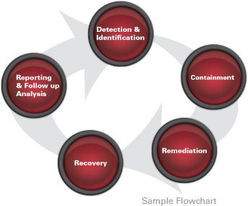
Figure 1 – Flowchart detailing basic incident response steps.

Attempts to ‘dive into’ the investigation risks damaging or destroying possible key evidence, therefore an investigator should ascertain the best possible means of identifying and retaining potential evidence even before they touch the suspect system. For example the decision to power off the suspect system for cloning or imaging purposes may provide the easiest method of examination, however doing so risks the possible destruction of volatile and network data, conversely attempts to conduct live acquisitioning risks possible network interference and cross-contamination.

Anecdotal evidence suggests the most experienced investigators use some form of methodology (i.e. flow chart) for use against systems they encounter, similar to that documented by Vaca (2005). Whilst this approach can prove useful, it is imperative investigators review the process before during and after the investigation. The ‘Do, Review, Apply” analogy works well here.

To that end, the following should be considered, established and conducted on arrival of the crime scene:

- Securing of the crime scene is of paramount importance. Damage limitation also extends to personnel.

- Photographic evidence of the crime scene and suspect system within context will aid scene reconstruction.

- Log, log and log some more! Documenting seizure, evidence and examination procedures is vital.

- Chain of custody is of paramount importance.

Additionally, the following should be considered:

- Scope, rules of engagement and anticipated outcome (i.e. civil or criminal prosecution) should be known from the outset.

- Practical steps for implementing the ACPO principles (7Safe, 4th Edn 2008), should be planned in advance.

- Identification, preservation, extraction, interpretation and presentation of evidence should be planned, discussed and documented in advance.

- Limitations (i.e. time, money and resources) should be factored in from the outset.

- Legal ramifications (i.e. contractual, liability, publicity) should be assessed at the earliest opportunity.

Section 2 – Identify, Preserve and Seize

Identification of both the system and peripheral devices whilst the prevention of cross contamination of all items deemed as possible evidence is important. Investigators should look to ensure the crime scene is as ‘clean’ as possible by securing entry and exit points, by the use of photographs and sketches of the surrounding area.

If possible the scene should be sealed by the use of a highly visible means ensuring other personnel are aware the location is out of bounds to non-authorised personnel (non-authorised being defined as those detailed by the investigator.

Equipment deemed relevant to the investigation should be photographed both in context and individually; with multiple photographs taken for each item.

It is incumbent upon the investigator that evidence; physical or logical, has been preserved, handled, transferred and examined in a forensically sound manner. Failure to do so leaves the evidence, investigator and their credibility in doubt. Evidence continuity and integrity must be, and seen to be, consistent throughout the investigation.
It is accepted that whilst the examination and transferral of evidence will alter the state of the system (i.e. power loss or powering up) it is imperative physical, logical or virtual state changes are documented in detail by the investigator. To that end, the following points are worth of note:

- Evidence marked for ‘bag and tag’ should be accompanied with seizure date/timings and accompanying case number annotated, as detailed in Figure 2.
- Documented notes by the investigator should also be logged.
- Transferral of evidence should be documented. Additionally where transferral between persons is likely, serial numbers and signatures of personnel should also be logged.
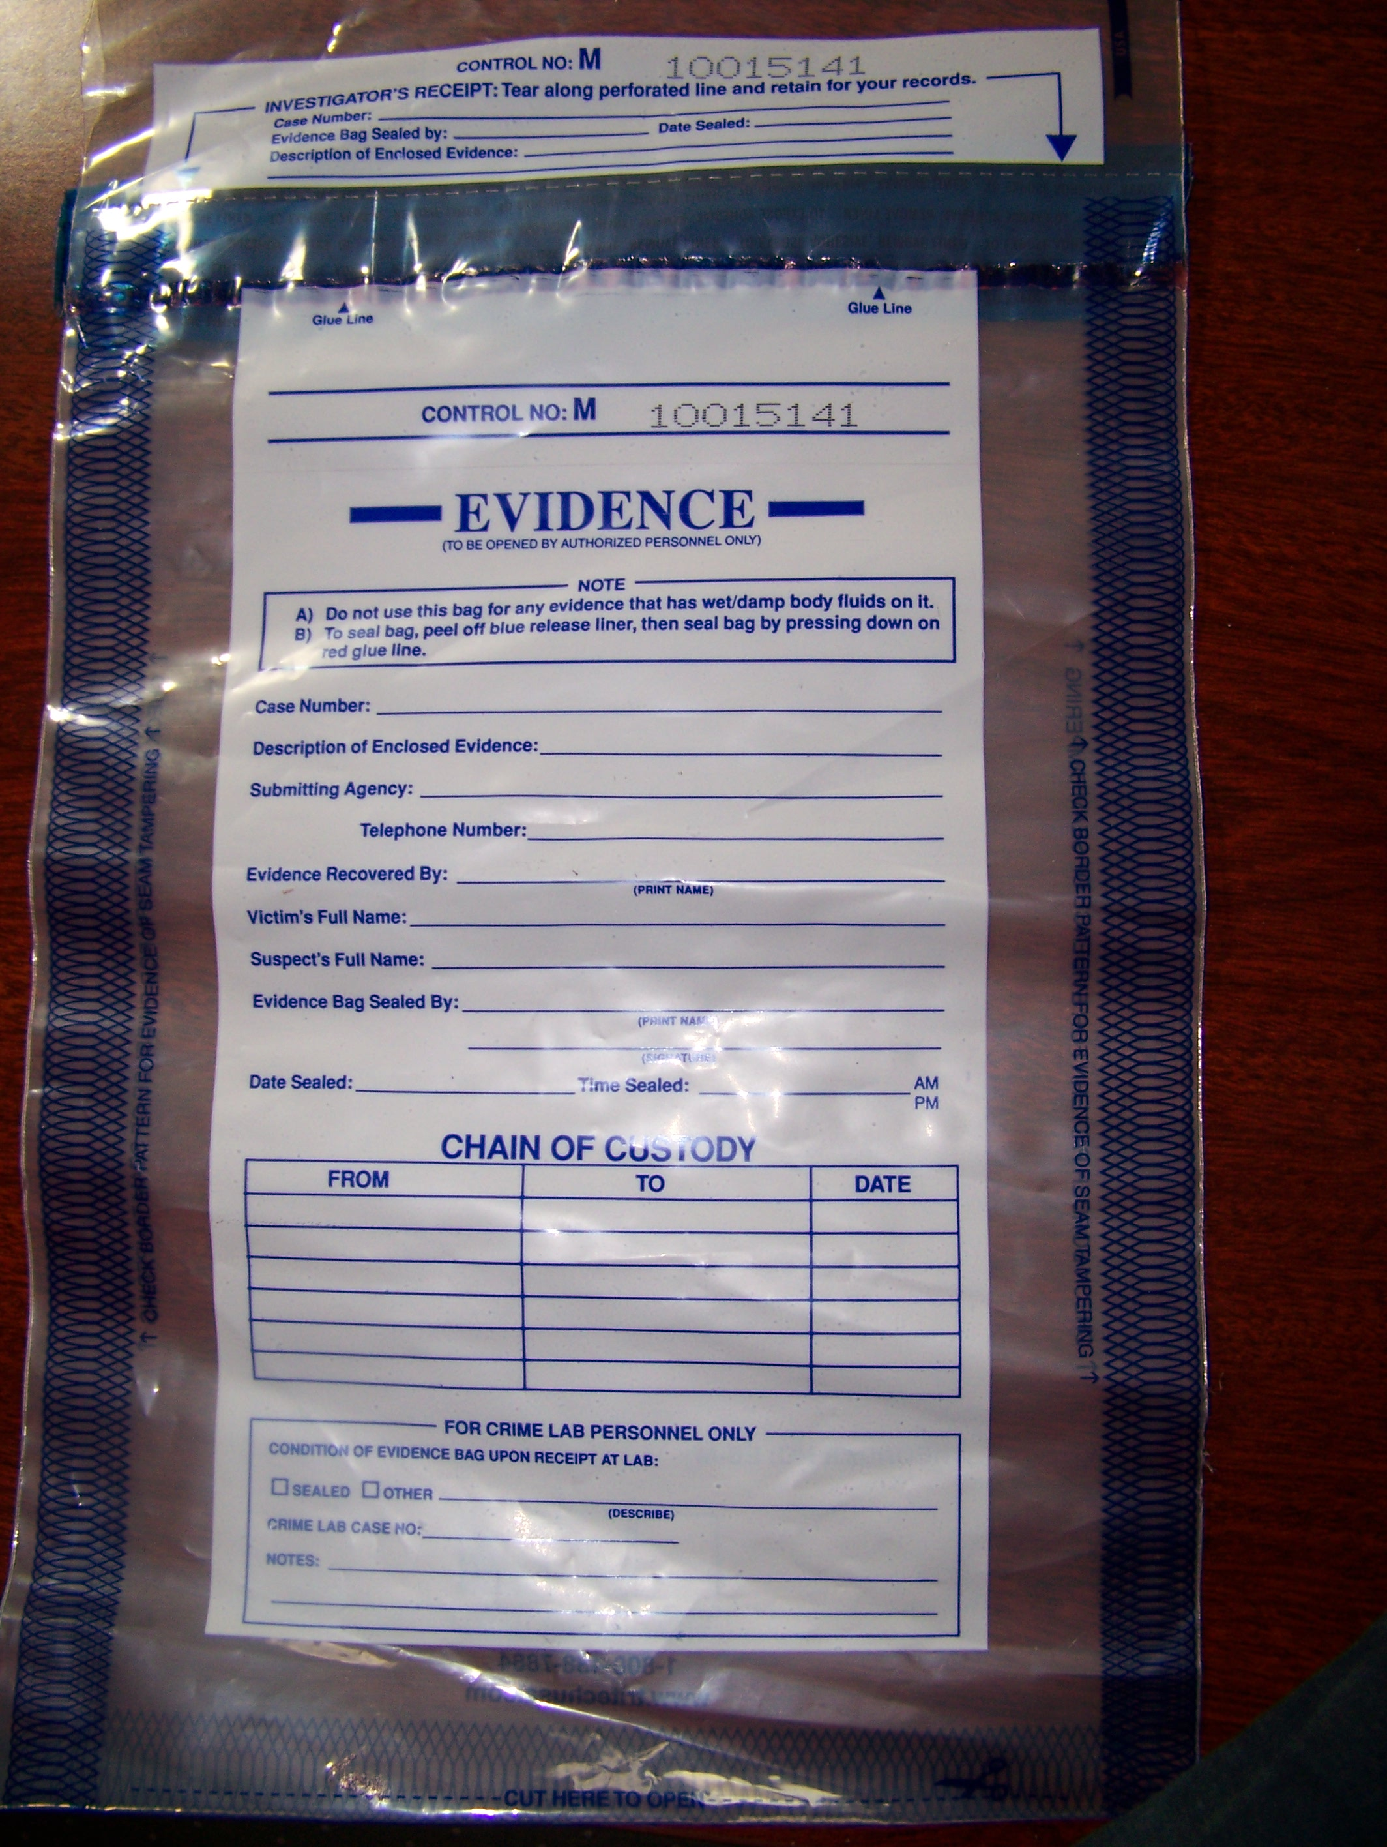
Figure 2 – Evidence bag; of note are the unique bag number; case number; evidence recovered by and chain of custody table.
Given that all systems, regardless of type, are vulnerable to electronic interference, protection of the system is paramount and the following should be observed:
- Volatile and non-volatile devices should be housed within anti-static bags.

- Removable media should be stored separately from all other devices. This ensures preservation of evidence whilst in transit.

- Transferral of assets, media and/or logs should be recorded.

- Ensure all evidence is kept apart from magnetic devices.

- All evidence bags should be labelled – instead of as the author as witnessed, the item itself!

- Containers used for storage must be secured at all times when not in use.

In this scenario, the investigator is aware of which system is likely to be eligible for seizure however this is rarely the case. Providing the identification process has been successful the following is worthy of note:

- Will seizure complicate data extraction or data harvesting (i.e. encrypted file systems)?
- How will data be handled after extraction – if extraction is possible?
- Can the preservation of data be assured?
Power on Self Test (POST) and the Operating System (OS) boot sequence instigate changes to non-volatile data (i.e. where data is retained) and the file system, therefore should the system be in a powered down state, the following should be observed:
- Label, sign and document all assets. This will facilitate a correct chain of evidence and enable an accurate re-construction during lab analysis.
- Non-technical information should be identified, logged and preserved (i.e. passwords).
- Printers, external drives and the like should be allowed to process outstanding tasks with the output being recorded and retained for further examination.
Alternatively, if the system is powered on, an investigator should be mindful of the following:
- Screen savers should be photographed prior to and after being interrupted with each action recorded.
- Networked systems provide an enhanced level of complexity. Volatile data will be lost should the system experience a power loss therefore specialists in network (live) data extraction or harvesting may need to be consulted.
- Screens which house images should be photographed. Note images containing paedophilia should be processed in accordance with the Sexual Offences Act; specifically the Protection of Children Act 1978.
If the system incorporates a Redundant Array of Inexpensive Discs (RAID) as shown in Figure 3; seizure may be particularly difficult. Additionally, financial and/or legal constraints may impede the removal of the system in its entirety; additionally the physical size of the system may make removal unrealistic. Nevertheless, should removal be permitted, an investigator should document and photograph seizure and examination whilst being mindful of the following:
- All RAID drives should be cloned.
- RAID systems should be sealed, labelled, dated and secured for later analysis.

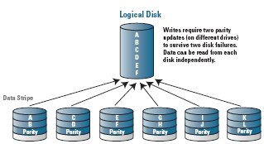
Figure 3 – RAID 6 configurations.
Regardless of whether cloning/imaging a live or powered down system, the integrity of the data is of paramount importance. To that end, an investigator should consider the following:
- Technical, competent personnel who have a thorough understanding of their legal responsibilities and their tool kit are the only people permitted to undertake a forensic examination.
- Standard and Small Computer Shared Interface (SCSI) write protect devices should be used for static and live cloning respectively.
- In situations where live or static imaging is not possible; booted analysis may be the only alternative. In this case only forensically sound software should be used.
Time stamps, used to catalogue events and processes, throw up potential reliability issues. An inaccurate clock on the suspect system, a differentiation in time zones (i.e. between the suspect system and investigators location) or deliberate clock alterations require validation and verification pre and post acquisition. Therefore the following should be noted:
- Use of an atomic clock should be used as a baseline for comparing atomic time to that of system specific time. The difference between both should be photographed and logged.
Imaging or cloning of Hard Disk Drives (HDD) or optical media may prove straight forward however volatile data is more difficult to acquire (i.e. Alternate Data Stream (ADS) or memory resident malware). Carvey (2005) states “...the ADS relies on the attributes associated with the primary stream. For example, if the hidden attribute is set on myfile.txt using the ATTRIB command, then by extension the ADS will also be hidden”

Investigators who have the ability to identify, extract, preserve and analyse such data enhance the possibility of a successful investigation.

Additionally, three other areas of a system which may provide an investigator with fruitful evidence:

- Slack space – blocks or clusters which contain partially deleted data.

- Swap files – using the HDD as a RAM replacement.

- Unallocated space – unmarked disc space.

In addition an investigator should also be mindful of the following:
- Creation, modification and access times may be affected by Anti Virus products.
- HDD may be examined in their entirety; however selective viewing may be necessary in order to ensure that only the appropriate information is viewed.
- Only repeatable, forensically sound output is acceptable.
Determining and retaining the integrity of any image or clone is paramount to any investigation. An investigator may have to produce evidence at a latter date is precisely the same as that as was retrieved from the system; therefore the use of either Message Digest v5 (MD5) or Secure Hash Algorithm (SHA) should be used.

Section 3 – Timeline Analysis
In order to determine whether certain files have been altered during the investigation, it may be advantageous to acquire evidence based on Modification (mtime), Access (atime) and Creation (ctime) times; although within a Linux environment the ctime is referred to as ‘change’ rather than ‘creation’. The MAC acronym is defined as:
- Modification – details the last time a file was written to or modified.
- Access – details the last time a file was executed or accessed.
- Creation – the initial creation time of the file.
Figure 4 shows an example of MAC times; additionally Windows (providing it uses NTFS) includes a forth acronym:
- Entry Modified – details the Master File Table (MFT) was modified. The MFT holds information on every file contained within the file system.
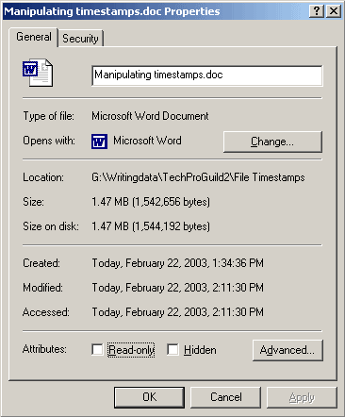
Figure 4 – Windows MAC Times.
There are certain benefits to MAC/MACE analysis such as:
- Events prior to and after an incident can be viewed. Useful for determining deleted, modified or executed files before during and after a timeline has been established.
- Handled at the OS level (as opposed to the network level); encryption or tunnelling issues can be overcome.
- Kernel modules and root kits can also be repressed given that the OS logs access to these files.

Investigators should be mindful that MAC (E) times whilst useful are highly sensitive to system changes, often during the analysis phase, leading to false positives and/or the destruction of evidence. Therefore it is useful to ascertain the MAC(E) times prior to issuing any other analysis on the system. To that end investigators should consider the following when producing dates and times within evidence:
- Source – can it be established exactly what generated the date and time?
- Accuracy – against what is both the time and date measurable?
- Relevance – is the date and time relevant to the investigation (i.e. can it prove or disapprove a supposition)?
Furthermore, an investigator should be mindful that anti virus products may alter time stamps. Additionally time stamps are based on the originators clock therefore incorrect Complementary Metal Oxide Semi-conductor (CMOS) settings on the suspect system or differences between acquisition and examination (i.e. acquisition slur) will affect the evidence timeline.
Prior to undertaking timeline analysis, certain points are worthy of note:
- MAC and date/time may be affected by anti virus products and or malware present on the system.
- Host clocks are responsible for creating timestamps – not the investigators system!

Section 4 – Internet History and Windows registry

Investigating web browsing history and attempting to reconstruct web activity may prove fruitful for an investigator. Open source and commercial tools allow for this form of analysis.
The predominant web browsers encountered on many corporate systems are usually Mozilla’s Firefox (or some Netscape variation) and Microsoft’s Internet Explorer (IE) with both browsers saving web history in their own unique way. Alternative browsers such as Safari and Opera may also be present, however for the purposes of this scenario only the aforementioned are discussed.
Browsing the internet allows IE (and all browsers) to store web queries, html files, icons and pictures to users HDD allowing for a quicker response or load time when browsing previously visited sites – known as the cache. IE uses a special file known as index.dat which acts as a pointer to this cached information. Note this cached information is user specific as is the index.dat file which maps to the directories listed previously. This ‘feature’ could be used by an investigator to reconstruct files and possibly ascertain the suspect’s web activity.
IE stores web browsing activity in various locations all of which should be investigated. On systems running Microsoft XP the default location for storing images and cached web pages is %systemroot%\Documents and Settings\*username*\Local Settings\Temporary Internet Files. Additionally %systemroot%\Documents and Settings\*username*\Local Settings\Temp\Temporary Internet Files is also worthy of investigation.
Conversely if the system is running Microsoft Vista, which ships with IE7, the following should also be analysed %systemroot%\%localappdata%\Microsoft Windows\Temporary Internet Files\Low\Content.IE5. N.B. these folders are often hidden by default and contain 3 files of note:
- Cookies – a text only file specific to a user’s preference on a specific website. Normally value dependant, it remains within the browser to aid user functionality.

- Cache – IE will attempt to load a web page from the system HDD. Off-line viewing is possible using this method.

- History – viewed as a collection (daily, weekly, monthly) every visited URL and date stamp is indexed.

Additionally, Firefox saves cached information to disk. Notable changes to the location of these files have resulted in all versions after 3.0 moving from the use of traditional history.dat files to a SQLite database. Of note the following files should be investigated located within the paths for XP and Vista respectively.

- Bookmarks – located within places.sqlite

- Cookies – located within cookies.sqlite

- Passwords – located within key3.db and signons3.txt

C:\Documents and Settings\<user account>\Local Settings\Application Data\Mozilla\Firefox\Profiles\<profile>

C:\Users\<user account>\Application Data\Roaming\Mozilla\Firefox\Profiles\<profile>

Open source tools such as CCleaner allow users to purge this type of data either during or after the browser session has ended, additionally the advent of ‘in-private’ browsing within IE and Firefox is making this form analysis more difficult, however information can still be retrieved using tools such as Access Data’s Forensic Tool Kit (FTK) which is excellent in viewing cached pages, alternatively Mandiant’s Web Historian has the ability to crawl directory structures looking for web activity using these browsers, with the ability to reconstruct analysed data into various readable formats.

Internet Explorer’s “InPrivate Browsing” available on IE v8 and Firefox’s “Private Browsing” available on v3.1.x has yet to be tested by the author; however articles from http://www.intaforensics.com/ (2009) claim “the feature offers no significant barrier to a successful investigation if computer misuse is suspected”.

Post Windows NT 3.1 (circa 1994) Microsoft incorporated its initialisation files from the classic.ini format to the Windows Registry. The registry is hierarchical database housing information pertaining to system settings, hardware components, software installations, network settings and user settings. Over the years many changes have been made to the registry; however it is still forms a key part of any Microsoft OS, and may offer valuable information regarding our suspect system. Additionally; sub-values of the registry should also be analysed to determine possible evidence.

If the file system on the HDD is missing, data carving may provide useful for information extraction. Data carving relies on and looks for boundaries between headers and footers; identifying known signatures instead of metadata and attempts to carve information based on the signature. Best conducted on an imaged HDD, data carving using FTK and Encase will identify signatures for documents, images, internet history, movies and other data with a unique identification pattern. N.B. signatures will be less reliable for text files given that no binary exists, additionally if the suspect system is Vista; data carving may be difficult given that Vista defrags every 7 days by default.
Additionally, keyword searching should also be undertaken; both at a logical (file level) and physical (disk level). It is important that a balanced and refined search is completed; too broad a search will result in an inordinate number of results being returned conversely searches which are specific may lead to evidence being missed.
Live, Indexed and Wildcard searches have certain benefits and disadvantages; however all three should be used in order to achieve maximum results:
- Live – ideal for searching for a specific or multiple strings; however searching can be slow.
- Indexed – ideal for investigations with no time constraints; however searching for irregular expressions is not possible.
- Advanced – ideal for wildcard or grep expressions with single, multiple or specific characters searching; however an inordinate amount of results may be returned.

Section 5 – Legal considerations

Given that organised crime is suspected, the investigator must be mindful of possible legal issues which may arise, specifically the need for reporting possible findings to the National High Tech Crime Unit (NHTCU); now part of the Serious Organised Crime Agency (SOCA).

The acquisition, analysis and extrapolation of data may be perceived as an every day occurrence; however it is incumbent upon the investigator to show the investigation has been; and is seen to have been, conducted in a manner which shows impartiality to the suspect, the crime scene and outcome. The ACPO principles outline best practice for the investigative process; however in this case an investigator should determine:

- Does evidence exist as a result of a user request, action or interaction?

- Does evidence exist as a result of an administrator’s request, action or interaction?

- Does evidence exist as a result of an automated computer function?

- If so, could this automated function be invoked without the user’s knowledge or interaction?

- Could evidence exist from malware infestation without the user’s knowledge?

Should the investigation recover evidence which points at the accused, the following should be considered:

- Is the evidence consistent with the user’s accessibility?

- Is the evidence timeline consistent with the user’s availability?

- Is the evidence consistent with user action or interaction?

- Is the evidence reliant on user specific knowledge (i.e. usernames and/or passwords)?

- Has the evidence been corroborated with any other known facts?

Discussion

Establishing which analysis environment to use is a key factor in determining the outcome. Investigators often have only one chance to retrieve evidence, therefore choosing the most appropriate environment whilst knowing the limitations of each technique is also important.
- Static – Considered to be the de-facto analytical environment. If physical access to the HDD is available, a flat forensic image can be viewed on the investigators system using conventional forensically sound software (i.e. Encase; FTK; X-Ways). However, the flat nature of the image poses limitations in that some forensic tools do not contain malware scanners.
- Mounted – With a clone of the suspects HDD directly connected to the investigators system, and with write protection in place, the clone can be viewed as a mounted logical drive using such software as Mount Image Pro or Encase Physical Disk Emulator (PDE), making it possible to scan the HDD for malicious software.
- Booted – By using virtualisation software (i.e. VirtualBox, Virtual PC etc), the investigator is able to clone, boot and view the suspect drive within its native environment (allowing malicious software to run). It should be noted that hardware limitations may be imposed (i.e. insufficient HDD space), additionally the author has noted – much to his cost; that RAID systems often re-initialise their disks if the controller detects a change of HDD within the array; as such they don’t react favourably to booted analysis.
- Live – Performed whilst the suspect machine is running. If the system houses business critical applications or services, this is often the only viable method of analysis. Furthermore, this form of analysis may be the only way to recover volatile or encrypted data. Investigators should be mindful that any malicious software installed on the suspect system may be active and that service degradation and data loss is possible.
- Live (Networked) – Similar to live analysis in that the suspect system is active, however this method allows viewing of network activity, useful for ascertaining which ports and/or communications are being used from both an internal and external perspective, it also allows for vulnerability scanning to be conducted. This form of analysis will make changes to the suspect system and some form of network isolation may be required to minimise cross contamination across the network.
Acquisition and analysis of computer based evidence is technically complex, therefore it is incumbent upon the investigator to present the evidence to technical and non-technical personnel in a manner they understand. To that end, the following should be considered:
- Authenticity; can the evidence link the suspect to the system and vice versa?
- Accountability; has the chain of evidence principal been adhered to?
- Integrity; is the evidence is relevant, accurate and complete?
In determining whether evidence meets the above criteria, the following should be considered:
- Could malware or anti virus products hindered, altered or affected the investigation?
- Is the ‘custody of evidence’ demonstrable – in other words can the investigator show that from identification to presentation the evidence has been handled in a forensically sound manner?
- Do physical, procedural or technical counter-measures exist which could prevent evidence being placed by others?
- Can the evidence be presented with brevity, clarity and simplicity?

Conclusion

Methodology whilst providing a framework from which to conduct a forensic investigation be viewed as a dynamic process, capable of being flexible enough to deal with differing lines of enquiry and other variables which present themselves during the investigative process.
Obtaining written confirmation, from senior organisational members that the investigation is permitted is vital. Scope, rules of engagement, pre-conceptions, expected outcomes and witness statements should also be documented in advance.
Seizure and identification of the suspect asset and surrounding areas will minimise the risk of cross contamination and play a key role in the evidence chain. The advent of digital cameras have enabled investigators to capture (both in still and motion) a crime scene in its entirety. The ability to photograph cabling and one-time-only situations (i.e. screen savers and clock settings) can help the reconstruction of the crime scene should it be necessary.
Investigators should pay particular attention to preservation, analysis and retention of volatile data. This information whilst notoriously difficult to capture may contain vital evidence within to the scenario.
Forensic tools whilst providing a sound method of evidence gathering also have limitations dependent on which tool and which environment they are being used and investigators must know and understand these limitations.
Data carving; keyword searches; internet history and timeline analysis should be conducted as a matter of course.
Advantages and disadvantage of each analysis/acquisition type (static, mounted, booted, live) should be understood intrinsically by all members of the investigative team as should the ability to capture or replay malware depending on which analysis type is being used. Furthermore, escalation procedures should be documented and briefed to all personnel in the event that analysis or malware detection results in damage to an organisations infrastructure.
Additionally, the following points should be observed:
- Only technical competent personnel with a thorough knowledge of their tool-kit should conduct an investigation.
- Chain or custody of evidence must be maintained at all times.
- Ensure the legal department have been informed of the investigation.
- Selective acquisition and analysis must be proportionate and relevant to the investigation.

- Can evidence be preserved – if so, how?
- Labelling and photographing evidence aids scene reconstruction.

Bibliography

Great Britain, Parliament, (Computer Misuse Act) 1990, Chapter 18, Amendment 2008, Office of Public Sector Information [online] [accessed 29 Jun 2009], http://www.opsi.gov.uk/acts/acts1990/UKpga_19900018_en_1.htm

Great Britain, Parliament, (Data Protection Act), 1998, Chapter 29, Office of Public Sector Information [online] [accessed 29 Jun 2009], http://www.opsi.gov.uk/Acts/Acts1998/ukpga_19980029_en_1

Great Britain, Parliament, (Lawful Business Practice,), 2000, No. 2699, Office of Public Sector Information [online] [accessed 29 Jun 2009], http://www.opsi.gov.uk/si/si2000/20002699.htm

Great Britain, Parliament, (Protection of Children Act), 1978, Ch 37, Office of Public Sector Information [online] [accessed 30 Jun 2009], http://www.opsi.gov.uk/RevisedStatutes/Acts/ukpga/1978/cukpga_19780037_en_1

Great Britain, Parliament, (Regulation of Investigatory Powers Act), 2000, Chapter 20, Office of Public Sector Information [online] [accessed 30 Jun 2009], http://www.opsi.gov.uk/acts/acts2000/ukpga_20000023_en_1

Great Britain, Parliament, (Sexual Offences Act), 2003, Chapter 42, Office of Public Sector Information [online] [accessed 01 Jul 2009], http://www.opsi.gov.uk/acts/acts2003/ukpga_20030042_en_1

ACPO, (2007), Good Practice Guide for Computer Based Electronic Evidence – 4th Edition, ACPO, National Hi-Tech Crime Unit (NHTCU) [downloaded 01 Jul 2009], http://www.7safe.com/electronic_evidence/ACPO_guidelines_computer_evidence.pdf

Anson, Bunting (2007), Mastering Windows Network Forensics and Investigation, Indiana, Wiley

Carrier, (2005), File System Forensic Analysis – Boston, Addison Wesley

Jones, (2005), Real Digital Forensics; Computer Security and Incident Response, Boston, Addison Wesley

Nelson, Phillips et al (2008), Computer Forensics and Investigations – 3rd Edition, Canada, Course Technology

Pogue, Altheide et al (2008), UNIX and Linux Forensic Analysis, Maryland, Syngress

Schroader, (2007), Alternate Data Storage Forensics, Maryland, Syngress

Vacca, (2005), Computer Forensics: Computer Crime Scene Investigation 2nd Edition, Charles River Median Inc. Boston

Walden, (2007), Computer Crimes and Digital Investigations – UK, OUP Oxford

