CIS007-6

NETWORK VULNERABILITY ANALYSIS

DISCUSS HOW NETWORK VULNERABILITY ANALYSIS CAN BE USED TO SYSTEMATICALLY FIND WEAKNESS IN THE SECURITY OF COMPUTER SYSTEMS THAT CAN BE EXPLOITED.

BY

CHRISTOPHER-CHARLES TAYLOR
(0811342)

COURSE TITLE: MSc Computer Security and Forensics (MSXCF)

TABLE OF CONTENTS

List of Figures. | Page 3
Abstract. | Page 5
Introduction. | Page 6
Chapter One – Scope. | Page 7
Chapter Two – Reconnaissance. | Page 8
Chapter Three – Network Discovery (Port Scanning). | Page 11
Chapter Four – Enumeration. | Page 15
Chapter Five – Gaining Access. | Page 18
Discussion. | Page 21
Conclusion. | Page 22
List of Acronyms. | Page 23
Bibliography – References. | Page 25

LIST OF FIGURES

Figure 1 | DNS Who is query – http://www.logicallysecure.com/ | Page 8
Figure 2 | Wireshark – http://www.wireshark.org/ | Page 10
Figure 3 | SYN / SYN ACK / ACK – http://www.certforms.co.uk/ | Page 11
Figure 4 | NMAP –sS output – http://www.insecure.org/ | Page 12
Figure 5 | NMAP –A output – http://www.insecure.org/ | Page 13
Figure 6 | NMAP –sU output – http://www.insecure.org/ | Page 14
Figure 7 | Tenable Nessus – http://www.tenable.org/ | Page 15
Figure 8 | Tenable Nessus – http://www.tenable.org/ | Page 16
Figure 9 | Command Prompt – net stat. | Page 16
Figure 10 | Command Prompt – net stat. | Page 17
Figure 11 | Command Prompt – net view. | Page 17
Figure 12 | MMC. | Page 18
Figure 13 | MMC. | Page 18
Figure 14 | Command Prompt – Telnet. | Page 19
Figure 15 | Command Prompt – Telnet. | Page 19
Figure 16 | Command Prompt – Telnet. | Page 20

Abstract
Network vulnerabilities are numerous, complex and evolving. The continued dependence on information systems, linked together in ever-larger networks, carries with it an increased risk of attack against key assets and sensitive information held in electronic form. There are broad spectrums of threats, from industrial espionage, the criminal fraternity, members of extremist groups, or even from individuals, either inside or outside the organisation, who are ill intentioned or simply curious.
Whilst attack vectors are dependent on numerous factors e.g. geographical/physical route of the transmission medium, the type of switching system used, the ease of finding and identifying the transmission, or the operating system itself and associated application, an important factor is that the attack vector, threat and loss of information usually go un-noticed until it is too late. Therefore, both the threat and attack vectors need to be managed adequately.
Unless controlled, computer and communication vulnerabilities create opportunities for unauthorised users to gain access and copy, or otherwise manipulate, the data held.
Network vulnerability analysis depends on a balance of measures to reduce the risk of compromise to an acceptable level, whilst ensuring that the Confidentiality, Integrity, Availability (CIA), Authentication and Non-repudiation of the information are maintained.

Introduction

The purpose of performing a Vulnerability Assessment (VA) is to identify weaknesses or vulnerabilities within an individual computer system or collection of systems, either by the use of automated tools, manual input by the tester or from a social engineering perspective. Vulnerabilities identified, enable an organisation to put measures in place to rectify, mitigate or manage them, whilst providing a greater understanding of the threat and possible impact on the organisation.

Threats to networked computer systems and the information exchanged between them can arise from:
- Unauthorised users of the system.
- Authorised users, who are curious, bored or disaffected.
- Software and/or Hardware Malfunction.

When considering vulnerabilities, the following additional factors should also be considered:
- Number of authorised users of the networked system and any interconnected systems.
- Security policies and measures for the system may not be mirrored to any interconnected system.
- Data passed between systems may hide malicious software or have its CIA compromised.
- Natural disasters – define and identify the threat, vulnerability and impact.
- Design, function and purpose of the system.
- Hardware positioning and software deployment.

This paper will attempt to outline the stages involved in conducting a basic Vulnerability Analysis (VA) on an IPv4 Microsoft ® Windows ™ network. Using the Open Source Security Testing Methodology (OSSTM v3 Accessed 2008), the VA will be conducted under the auspice of a “tandem test” and broken down into 5 different components:

- Scope.

- Reconnaissance (Footprinting).

- Network Discovery (Port Scanning).

- Enumeration.

- Access.

Each component will outline how the security posture of a networked computer can be analysed and assessed, whilst results from VA tools can demonstrate if this posture is weak and possibly compromised. The tools used to conduct the VA are from the open source community, and whilst common attack techniques are documented, specific system vulnerabilities are not.

It is perhaps pertinent to differentiate between the terms VA and Penetration Test (PT). Whilst a VA will attempt to identify weakness or vulnerabilities within a system, it will normally stop short of gaining access to systems (scope dependant), with vulnerabilities highlighted and recommendations given to ensure the risk of compromise is reduced.

The premise of a PT is to conduct as many, if not all, of the stages of a VA taking the additional step of gaining access to the system.

NETWORK VULNERABILITY ANALYSIS

Chapter One – Scope

Scope is what differentiates a legitimate VA from an unauthorised attempt to access a system, series of systems or the access, collation and storage of information. It cannot be overstated enough how important the definition of scope is, prior to any technical testing being carried out. As a minimum, a tester should discuss and detail the following aspects of the VA with the organisation:

- Timeline for testing, specifically date(s) and start-finish time.

- Confirm the type of engagement – black / grey / white hat system testing.

- Location for testing is consistent with Health and Safety laws.

- Confirm the customer requirements and expectation. What is the tester trying to prove?

- Determine the customer’s expected output. What will the tester give the customer?

- Confirm the customer’s input to the test – Will the tester be supplied with a network topology, credentials?

- Confirm tester’s starting point – IP addresses, behind/in-front of firewalls etc.

- Contact details – technical and managerial.

- Confirm what is out of scope.

- Detail all of the above in a written document – signed by both technical and managerial staff.

Failure to determine a detailed written and signed scope prior to any form of testing may render the test invalid and the tester vulnerable to legal action taken against him. A Statement of Agreement (SOA) or detailed legal documentation is outside the scope of this paper, however as a minimum, both tester and customer should be aware of:
Computer Misuse Act (CMA) 1990 – The CMA outlines the rights of an individual or organisation in the event of an unauthorised attempt by any party, through attempted manipulation, actual penetration or subversion of computer systems. Section 3 of the act mandates “(1) A person is guilty of an offence if — (a) he does any act which causes an unauthorised modification of the contents of any computer; and (b) at the time when he does the act he has the requisite intent and the requisite knowledge.” (Great Britain. Parliament. 1990. Computer Misuse Act 1990, Chapter 18, Section 3)

NETWORK VULNERABILITY ANALYSIS

Chapter Two – Reconnaissance

The next step of any VA is to gather in advance, as much information as possible about the target system. This process is referred to in various ways; reconnaissance, profiling or scoping, however regardless of the name, it is the start of a systematic and methodical approach of a VA. Often time consuming and arduous, it is one of the most important steps that can be performed by a tester. Many different forms of reconnaissance should be conducted prior to a VA, with the type of reconnaissance dependent on numerous factors, time constraints perhaps being the biggest. Anecdotal evidence suggests that reconnaissance can be performed in two ways; passively and actively.

Passive Reconnaissance:

As the name suggests, this type of reconnaissance is aimed primarily at accessing publicly available information through the Internet. The growth of the Internet has ensured that corporate publicity is widespread and instantly available. Organisations publicise all manner of interesting facts about themselves, and this information (names, personal details, business locations, e-mail addresses, domain names, IP addresses,) all of which can be catalogued and archived ready for use against them at a later date. It is difficult to define or document a ‘check-list’ or step-by step guide to passive reconnaissance as many activities will lead a tester down many different avenues; however the ability to access this information is dependent on an internet connection, a web browser, a little bit of curiosity and lot’s of patience.

One of the most basic methods of passive reconnaissance is to interrogate one of the Domain Name Server servers that serve the Internet. As part of the registration process of DNS, the Internet Corporation for Assigned Names and Numbers state that the Domain Name Registrar “must timely populate whois data, must timely submit updated registration information and must provide public access to whois” (ICANN, Accessed 16 Oct 2008]. Whilst this information may be required for registration purposes, it gives the tester a means of extracting more information on the target. One of the VA tools a tester can use is ‘Whois’.

Shown below, Figure 1 displays a simple ‘Whois’ DNS query against http://www.logicallysecure.com with the interesting output highlighted.

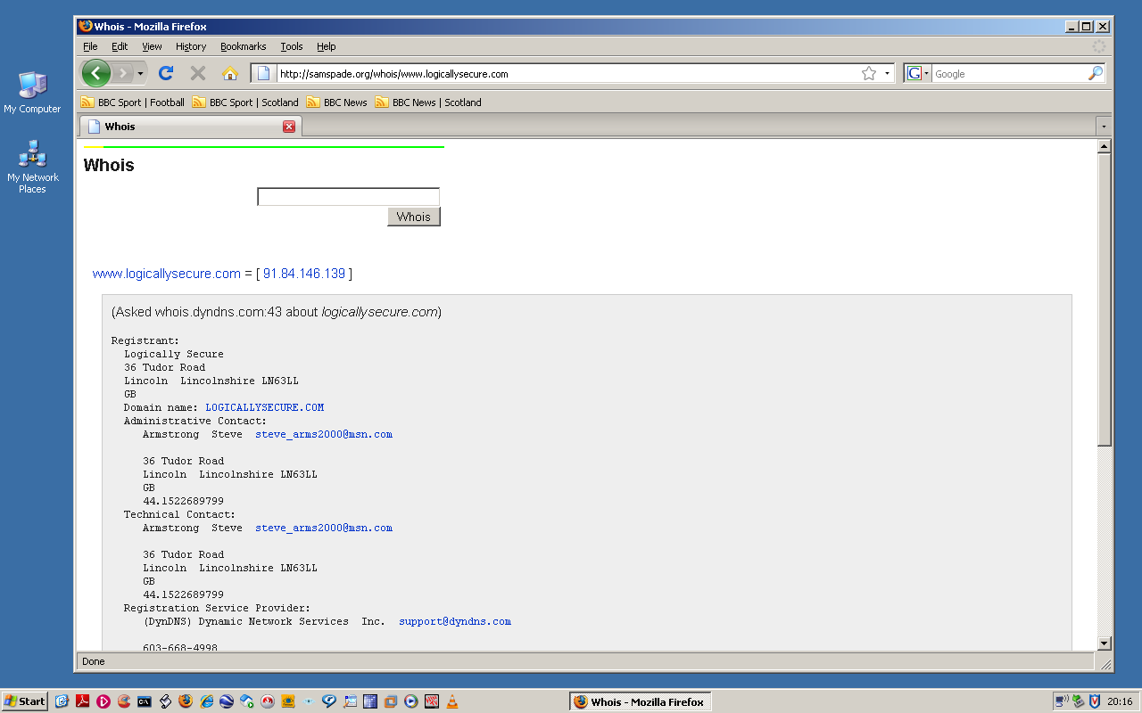 Figure 1 (Whois DNS query)

Consistent with the information required to register a DNS name, we can see from Figure 1 some interesting information about the target: IP address, registered location, administrative and technical contact as well as an email address and contact telephone number. Armed with this information, a tester can now use this as an avenue for further reconnaissance.

Mirroring the website (i.e. saving a cached copy locally) is often useful and serves two purposes; firstly the tester is able to inspect the source code for items of interest of the main site, and if there are other sites linked to the main site, the linked site may not be as security minded as the target and information leakage may be prevalent.
If, as demonstrated in Figure 1, location and address details are disclosed other vectors of reconnaissance may be possible, such as dumpster diving, the electoral roll, physical surveillance or social engineering, although it should be noted that permission to conduct the latter should be gained in writing in advance conducting the VA (see scope!) – The author has fallen foul of this oversight!!

Other avenues are worthy of exploration, leakage of phone numbers and e-mail address can be researched further via newsgroups and Usenet discussion forums. Indeed, if the email address is displayed a tester can make a reasonable assumption of similar types of email addresses linked to the target. Additionally, the emergence of social networking sites has led to people posting up personnel and organisational information often with no perception of security. Taking the time to do creative and thorough searches will prove to be beneficial, both for a tester and the target.

Active Reconnaissance:

If and when passive reconnaissance has been exhausted, the tester should turn his attention to active reconnaissance, which can be conducted from within the organisation. During this phase, the tester should study copies of security risk management documents (i.e. risk registers) to ascertain which (if any) previous vulnerabilities have been identified and risk managed locally.

From an observational and communicative standpoint a tester should also ascertain the following:

- Do senior management support and promote active security risk management?
- Does the organisation culture support and reward prudent risk taking?
- Is there an effective security risk communication process?
- Are authority, responsibility and accountability delegated clearly?
- Is capability and capacity aligned to responsibility and accountability?
- Is the security risk control process proportionate, dynamic and flexible?

Information gleaned from this type of observation may give a tester a flavour of what may be expected when the more technical matters of the VA are performed. Furthermore, a tester should also consider some form of basic network reconnaissance.

Failure to conduct reconnaissance in a detailed and controlled manner, risks the possibility of key pieces of information related to specific technology, organisation or person being missed. The necessity and usefulness of reconnaissance is perhaps best encapsulated by (McClure, Scambray et al 2005) “Any piece of information that provides insight into the target organisation’s privacy, technical details regarding hardware and software used to protect the organisation can be useful to an attacker.”

Information detailed within the scope regarding IP address and network positioning may be correct, however a tester should confirm that his positioning on the infrastructure is in-line with his scope and expectation.

One of the VA tools used to conduct this reconnaissance is “Wireshark”. This tool, as detailed in Figure 2 whilst presenting no risk to the network will display numerous pieces of information to interest the tester: IP address, Media Access Control (MAC) address, and protocols in use.

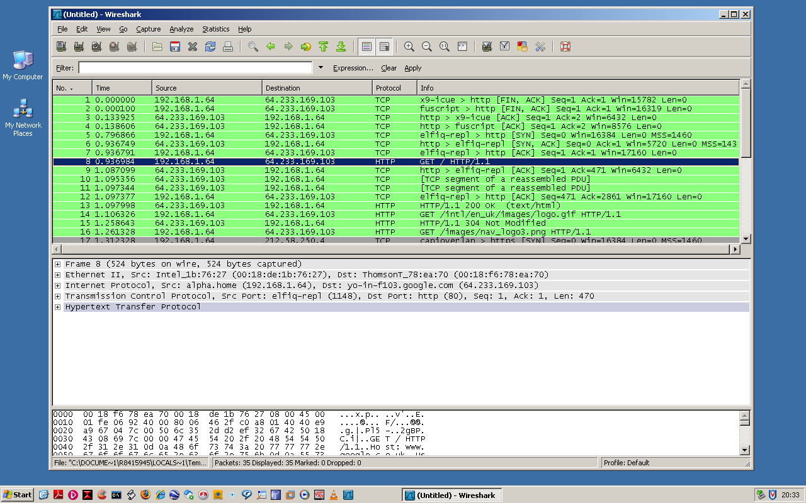 Figure 2 (Wireshark Output)

Only after the tester is convinced that his location on the network is where he expects it to be should the next step of a VA be performed.

NETWORK VULNERABILITY ANALYSIS

Chapter Three – Network Discovery (Port Scanning)
If scope and reconnaissance are construed as arduous, time consuming and at times possibly boring, then network discovery (port scanning) is where the fun aspect of a VA begins.
Perhaps a good analogy for port scanning would be to imagine standing in front of a house, from a distance you can see the windows and doors; however you are unable to determine which window or door is open. Not until you get closer and attempt to open the windows or doors can you ascertain what is opened or closed. Port scanning is the process of querying ports (doors) and services (windows) to identify what is running on a computer system or other networked devices.
One of the first steps of port scanning is to ascertain which systems are both active and interesting. Scanning every port on every host is slow and usually unnecessary; however a tester should always be mindful that the use of high ephemeral ports for applications are now becoming more common, and that what makes a host interesting depends greatly on the scan purposes.
Administrators may only be interested in hosts running certain applications, whilst a tester could be concerned about the entire IP range. Alternatively, administrators may be comfortable using the ICMP ping to hosts on their internal network, whilst a tester may use dozens of probes in an attempt to evade various restrictions that may be in place.
Over time, a number of techniques have been developed for surveying protocols and ports on which a host is listening, all of which offer different benefits and problems. The tester’s mindset should be to probe as many hosts and record as many ports and services as possible, keeping track of the ones that are receptive or useful to his particular need.
Prior to attempting any port scan, it is important for a tester to understand some of the basic concepts of the protocols used, in particular the differences between Transmission Control Protocol (TCP) and User Datagram Protocol (UDP):
TCP – is a connection-orientated protocol:
TCP connections are initiated normally by the client sending a synchronised (SYN) packet to the server. The server responds with synchronised/acknowledgment (SYN ACK) packet which confirms the servers availability. Finally the client sends an acknowledgement (ACK) packet and the transmission of data begins. However, before a client attempts to connect with a server, the server must first bind to a port to open it up for connections: this is called a passive open. Once the passive open is established, a client may initiate an active open.
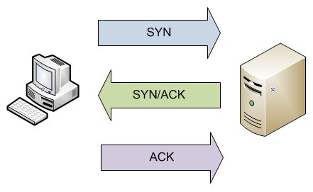 Figure 3 (TCP Three way handshake)
UDP – is a connectionless protocol that does not guarantee reliability however due to the lack of error checking overhead UDP is faster and more efficient.

There are a range of port scanners available from the open source community or from proprietary sources; however NMAP (Network Mapper) is considered by many testers (and rightly so), to be the de-facto port scanner.
Figure 4 outlines a basic NMAP scan, the syntax is as follows:
nmap -sS -n -p- 192.168.1.65 –oX vulnerabilityanalysis.xml
Translated, the author has instructed nmap to conduct a SYN scan (-sS), disregard any available DNS servers (-n), scan the entire TCP port range (-p-), against the IP address 192.168.1.65 and output the results to an .xml file (-oX), which NMAP will create, and name it vulnerabilityanalysis.xml.
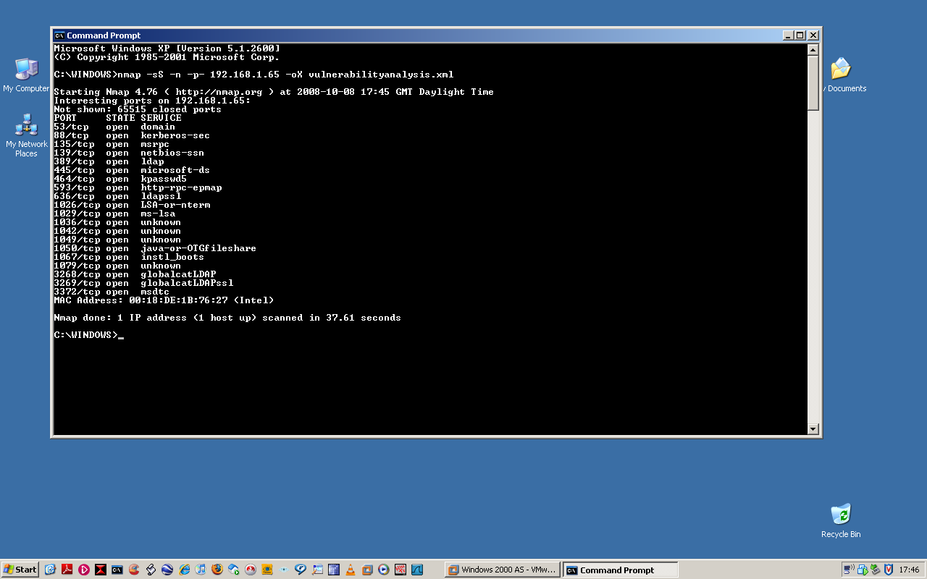 Figure 4 (nmap output)
Figure 4 reveals some interesting results, namely port 139 (NetBIOS), 445 (Microsoft-ds) and 3268 (Global catalogue LDAP) all appear open.
The benefit of performing this type of scan is that NMAP never completes the three-way handshake. It sends a SYN packet to the host system and duly receives the SYN/ACK response; however instead of returning an ACK packet NMAP sends a reset (RST) packet and assumes the port is opened based on the response of the host.
SYN scanning can scan thousands of ports per second (infrastructure dependant). Since no connection is completed, its relative stealth makes it useful for bypassing any firewall restrictions that may be in place. Note that NMAP provides other switches which can increase the level of stealth, however for the purposes of this project, the –sS has been used.
SYN scanning has benefits; however its unobtrusiveness mean information may be limited. It is therefore important for a tester to run a series of more obtrusive scans in order to reveal further details and possible weaknesses on the host emphasising the point made by (McClure, Scambray et al 2005) “security through obscurity is not your first line of defence…if an attacker were to know the operating system they should have a difficult time obtaining access to the system”

Outlined below, Figure 5 displays a full TCP connect scan, the syntax is as follows:
nmap -A -n -p- 192.168.1.65 –oX vulnerabilityanalysis2.xml
Translated, the author has instructed nmap to conduct a full TCP connect scan, incorporating both OS and version detection (-A), disregard any available DNS servers (-n), scan the entire port range (-p-), against the IP address 192.168.1.65 and output the results to an .xml file (-oX), which NMAP will create, and name it vulnerabilityanalysis2.xml.
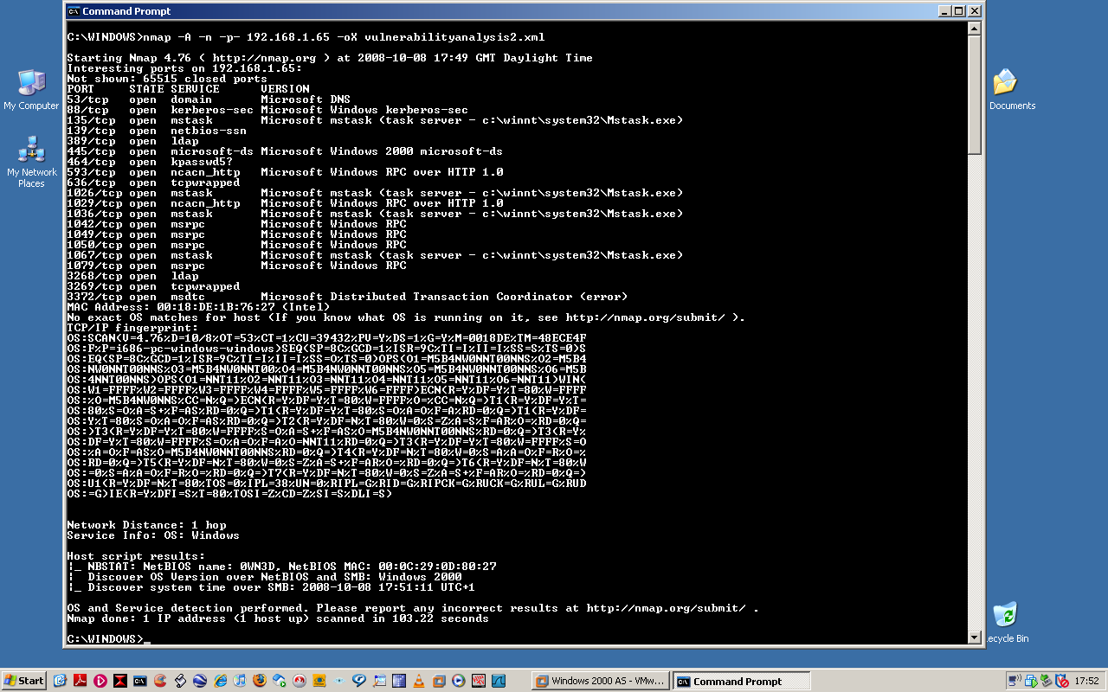 Figure 5 (TCP output)
Figure 5 shows that whilst using the –A switch may be more obtrusive, it also reveals more information about the host, specifically that port 445 is opened (as shown in figure 4), the OS version associated to the Microsoft-ds service is also displayed, which is further confirmed at the bottom of the screen. Note also the MAC address for the target host. Scope permitting, this information may be useful for any future spoofing attempts.
This information now gives the tester a more detailed knowledge of the OS, which ports are opened and what services are running on those ports. It now allows the tester to focus his vector of attack vector and by using other tools he may be able to expose other weaknesses in either the OS well or associated application, and emphasises the point made by (McNab, 2004) “It is never impossible for a hacker to break into a computer system, only improbable”.

Whilst the majority of applications run over TCP, it is important for a tester to understand that the services/applications running over UDP are just as important for determining the weaknesses of a system. For completeness, a UDP port scan should be run on each scoped host. Due to the unique properties of the protocol (see page 14), scanning the complete UDP port range may be time consuming and unreliable, nonetheless, it is imperative that a tester attempts to determine which, if any UDP ports are opened and what services are running on them.
Figure 6 outlines a full UDP scan using NMAP, the syntax is as follows:
nmap -sU -n -p- 192.168.1.65 –oX vulnerabilityanalysis3.xml
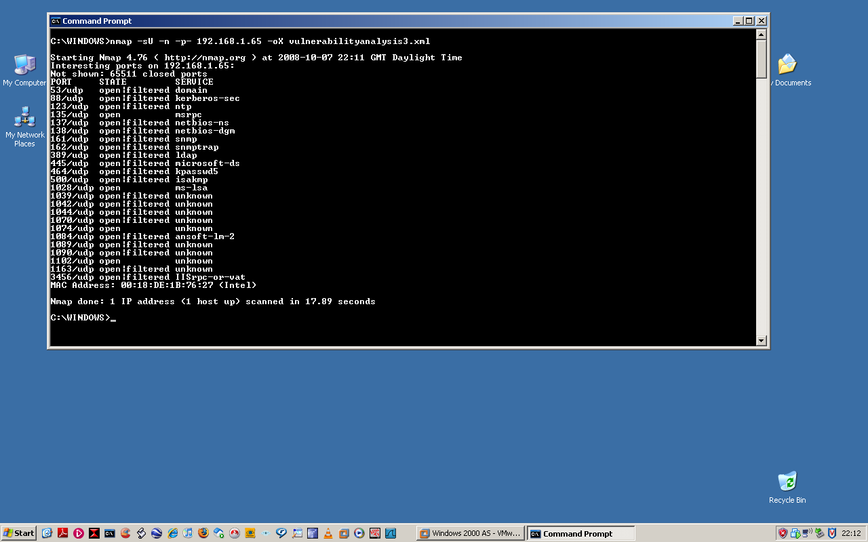 Figure 6 (UDP output)
Similar to the –sS scan shown earlier, the author has instructed NMAP to conduct a UDP scan (-sU), disregard any available DNS servers (-n), scan the entire UDP port range (-p-), against the IP address 192.168.1.65 and output the results to an .xml file (-oX), which NMAP will create, and name it vulnerabilityanalysis3.xml.
The output reveals interesting results, namely that port 161 appears to open|filtered. Based on the scan type and nature of the UDP protocol, the tester cannot be certain whether the port is opened or closed, therefore the tool suggests further analysis by the tester may be required.
There are other methods a tester can, and should use to clarify whether the port is opened. Should further investigation reveal the port is opened; there are other VA tools available to extract more information.

NETWORK VULNERABILITY ANALYSIS

Chapter Four – Enumeration
Depending on the testers’ scope, reconnaissance and port scanning results, the next step of a VA is to make active connections to a system or application in order to reveal more information and weaknesses about the target that could aid the tester in compromising the system. This process is referred to as Enumeration.
Enumeration, whilst sharing similarities to port scanning, demands a much more focused and in some instances a more intrusive approach to testing. The level of intrusiveness will often result in some form of information leakage from the target host, which in turn may give the tester a more detailed perspective of system vulnerability and a more focused attack vector.
Enumeration is a very platform specific function (i.e. enumeration of the rlogin daemon used in UNIX is not normally available on a windows host), whilst numerous forms of enumeration techniques exist,
- Banner Grabbing.
- File Transfer Protocol (FTP).
- Hyper Text Transfer Protocol (HTTP).
- Simple Mail Transport Protocol (SMTP).
- Simple Network Management Protocol (SNMP),
the author will give an extremely brief history of the NetBIOS protocol before demonstrating one of the most basic and devastating forms of NetBIOS enumeration techniques still in use today.
The NetBIOS protocol was developed for use by IBM ® ™ circa 1986 offering broadcast, communication and registration services for systems either unwilling or unable to use TCP/IP. The protocol is gradually being phased out due to the fact that TCP/IP is now the de-facto standard for communicating, particularly over the internet, however the continued inclusion of the protocol on many internal networks for legacy purposes ensure an attack vector may still be valid.
One of the best open source VA tools to establish whether the NetBIOS Null Session share is a viable entry point into a system is by using Nessus. The tool is very granular offering many configuration variables, hence only the results are shown in Figure 7 and 8 with the interesting points highlighted in red.
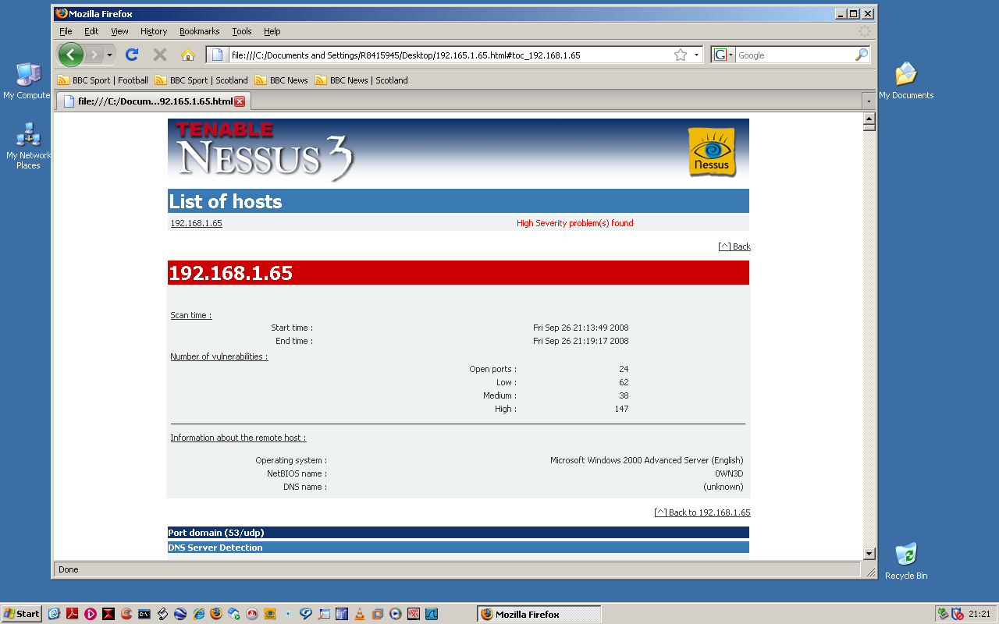 Figure 7 (Nessus Output)

Nessus reports in Figure 8 that the target system allows a null session (default username of administrator and no password assigned) connection to the host via Server Message Block (SMB). Technically speaking, SMB operates at the application layer of the OSI layer; however it is interlinked with the NetBIOS protocol, so the tester can deduce that if SMB allows a null session – so may NetBIOS.
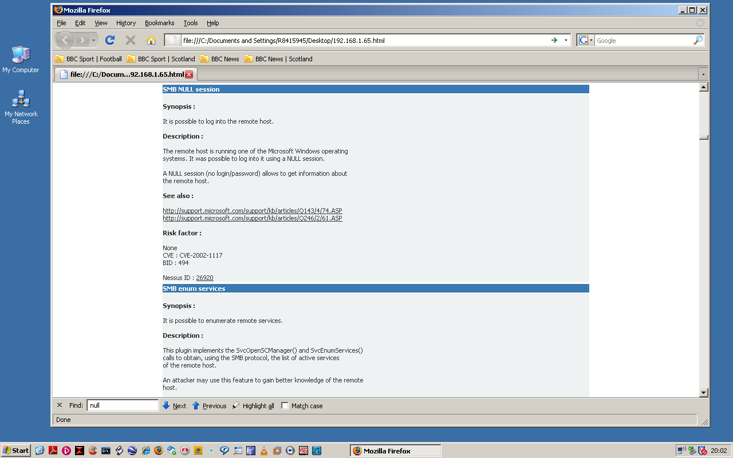 Figure 8 (Nessus Output)
It is also important for the tester to establish whether the output from Nessus is correct or whether he is looking at a false positive, therefore further investigation in the command line is necessary.
Figure 9 shows the output from a basic netstat command ran on the tester’s machine prior to attempting an attack. There are 6 TCP connections listed, all of which have been established on the localhost with a dynamic port number allocated – i.e. the connection has been established on the tester’s own system.
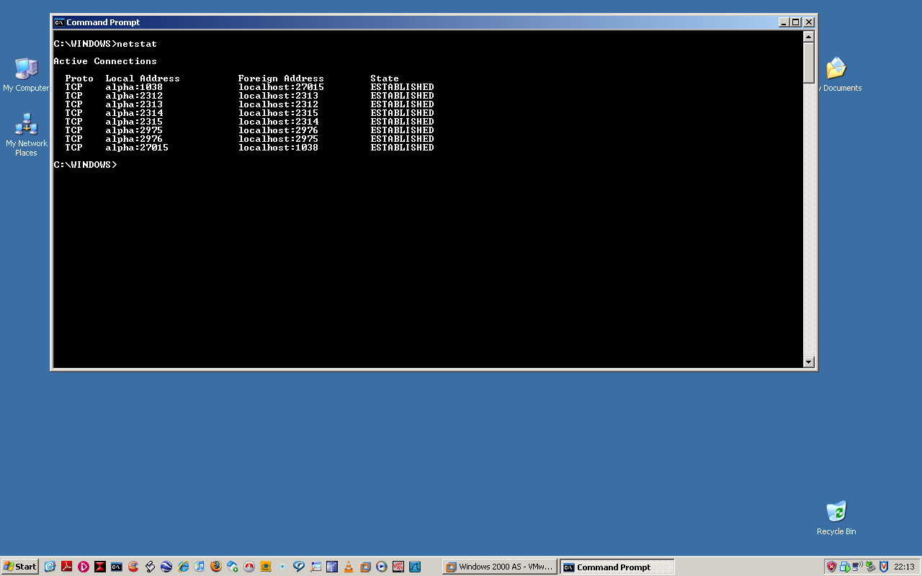 Figure 9 (Netstat)

From Figure 8 we established that the host accepts Null Session connections. In Figure 10, the tester attempts to connect to the target system using the net use command and following syntax:
net use \\192.168.1.65\IPC$ “” /u: “” – Translated the tester has instructed his system to connect to a shared resource (net use) on the target system (IP address), specifically the Inter Process Communication share (IPC), (the dollar sign indicates the share is hidden from normal users) using no password (“”) and connecting as an anonymous user (u:””). Note the command completed successfully and that a connection has been established on the target system.
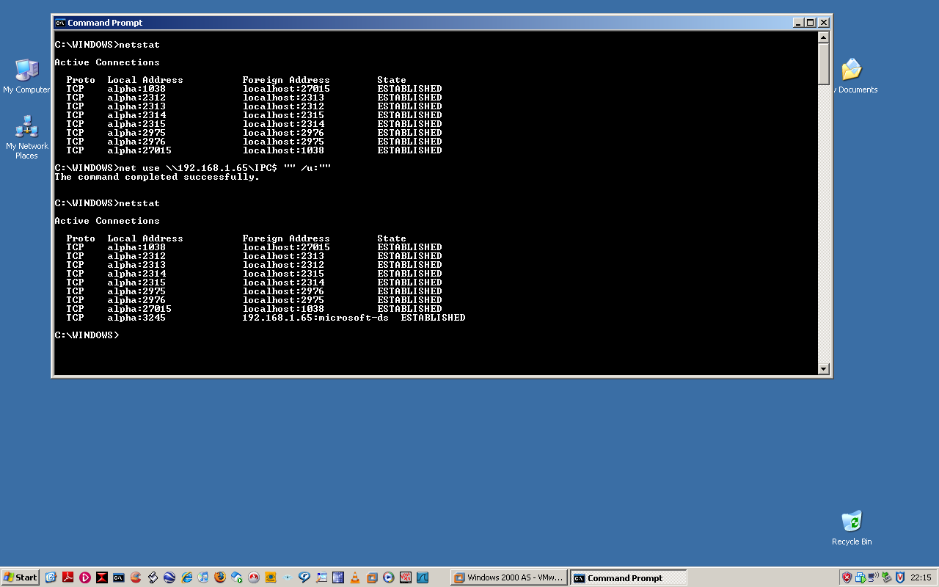 Figure 10 (Netstat)
Figure 11 shows the net view command, the syntax is as follows:
net view \\192.168.1.65 – Translated the tester has requested to view a list of shares on a remote computer (net view), specifically the shares on the following IP address (192.168.1.65). Once again the command completely successfully, allowing the tester to view what other shares are available on the target. This information used in conjunction with the information in Figure 4 (port 3268 is open) is indicative of a Domain Controller (DC) and indicates unrestricted access to the DC may be imminent.
Note that throughout the VA process each part of information has been extracted, developed, added together and then viewed as a whole. The process is perhaps best described by (Mitnick and Simon 2002) “Just like pieces of a jigsaw puzzle, each piece of information may be irrelevant by itself. However, when the pieces are put together, a clear picture emerges”.
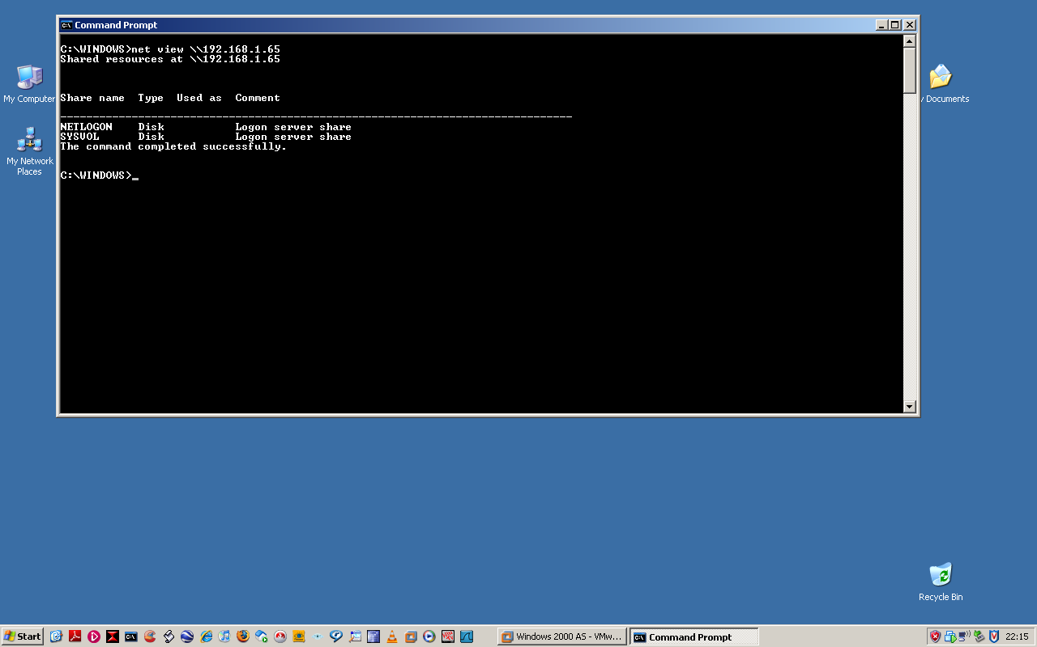 Figure 11 (Net view)
NETWORK VULNERABILITY ANALYSIS

Chapter Fiver – Gaining Access

Prior to attempting access to any system, a tester should check (and double check) both his scope and authority. It cannot be emphasised enough that whilst a tester may be brought into an organisation to conduct a VA, the line between VA and PT is not immediately obvious. However, the author is confident the tester’s scope allows him to gain access through vulnerabilities identified, ergo the next stage of the VA is to gain and retain access either for a prolonged period of time or until the VA has been completed – whichever is soonest.

Figure 12 shows the Microsoft Management Console (MMC), specifically the Computer Management (Local) snap-in on the tester’s machine.

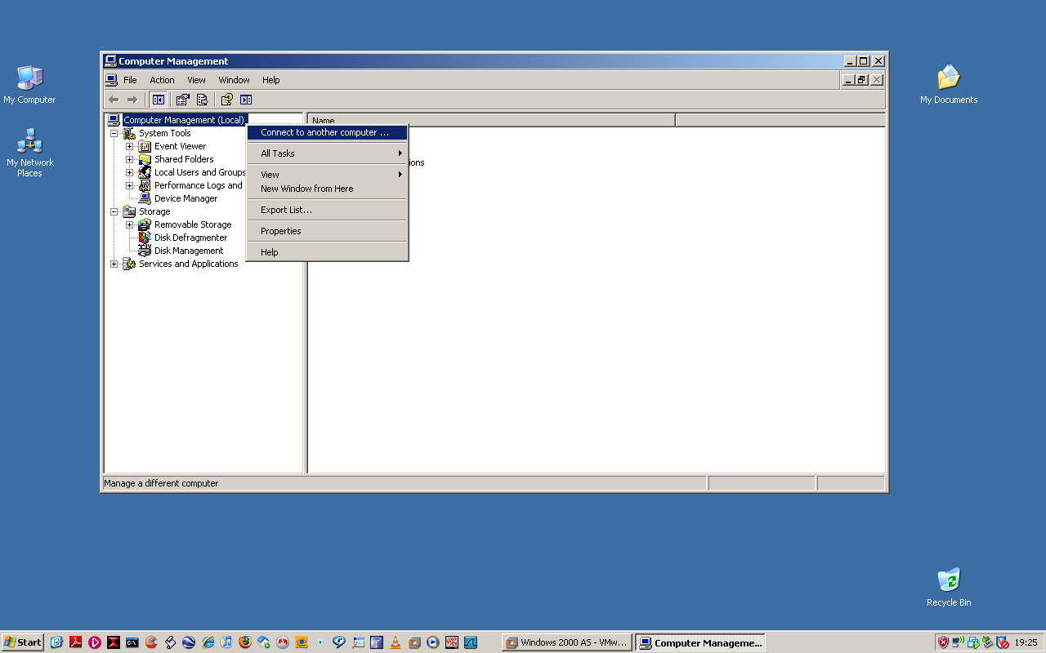 Figure 12 (MMC)
Due to the SMB/NetBIOS vulnerability identified earlier, the tester is able to connect to the target system as shown in Figure 13. The snap-in, this time on the target system allows limited access to administrative functions. Neither Figure 4 nor Figure 5 revealed that the Telnet service (TCP port 23) was running; however the tester can now enable this service, opening up a new attack vector.

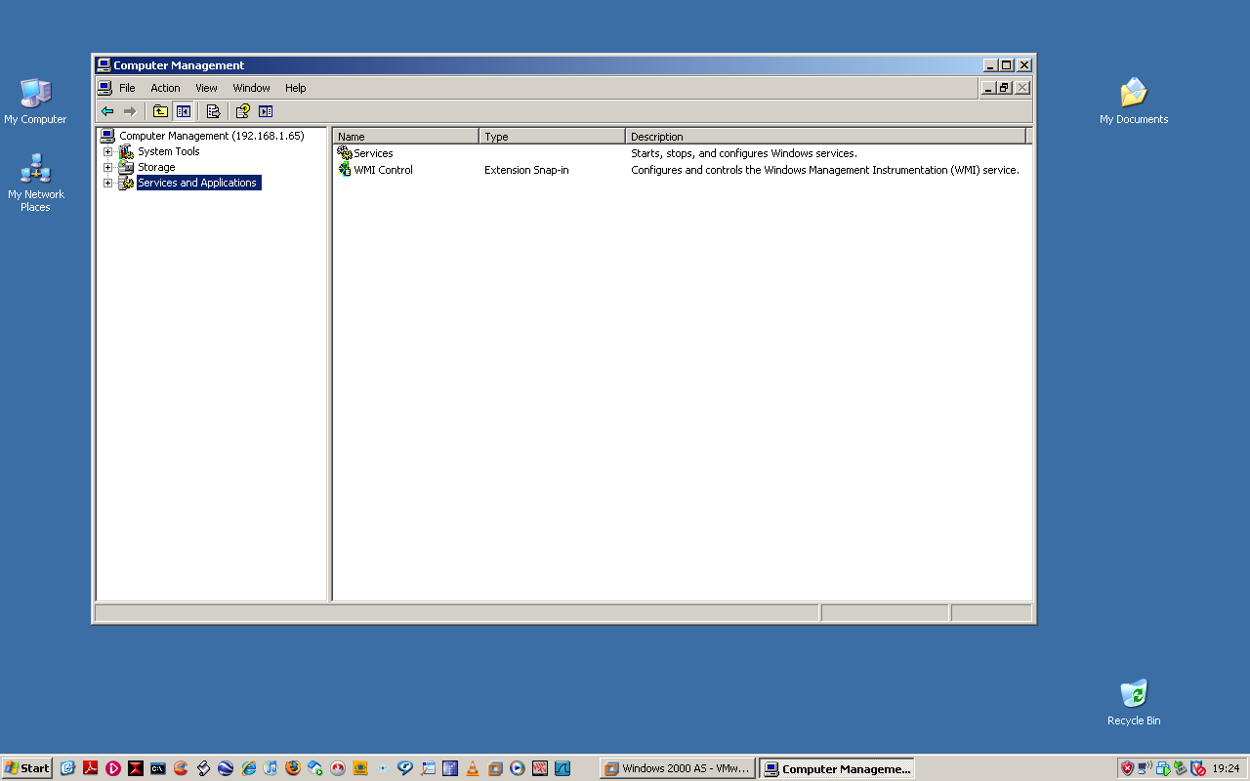 Figure 13 (MMC)

Figure 14 confirms the Telnet service is started and a connection made on the target host.
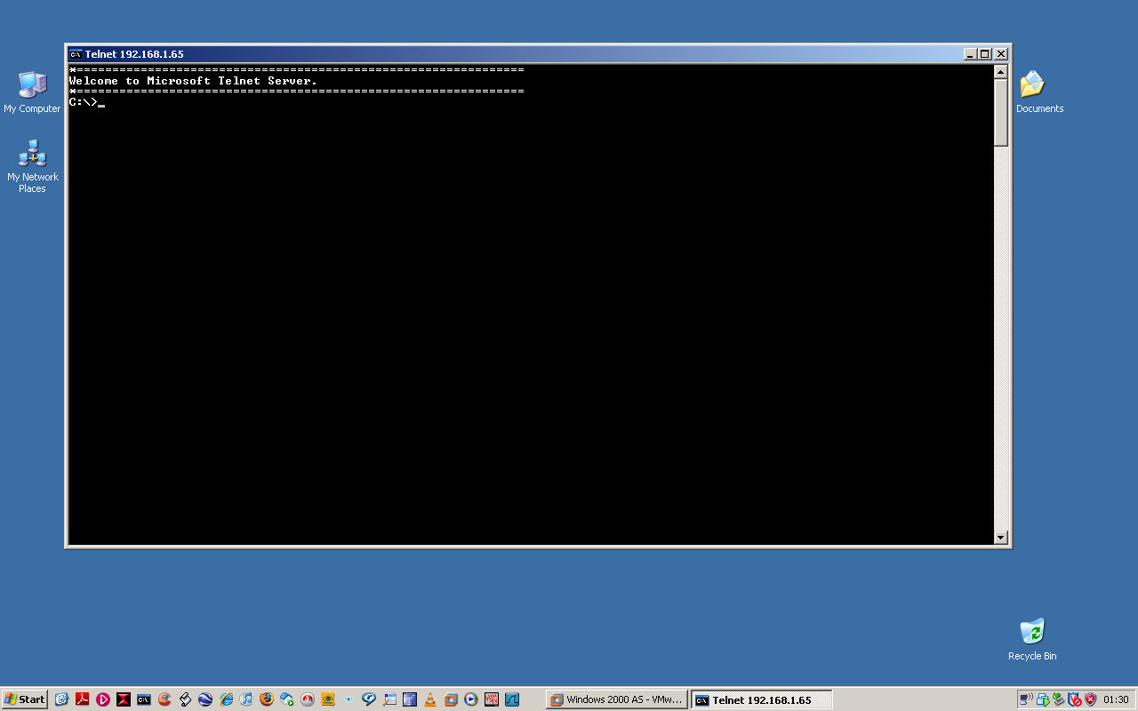 Figure14 (Telnet)
Figure 15 displays the syntax to add a username and password to the target system:
net user hacker strongpassword /add
Translated, the author has instructed the target to create a username of ‘hacker’ (net user hacker), assign a password to that username of ‘strongpassword’ and ‘add’ (/add) the user to the Domain Users group. Note that because the target has been identified as a DC, the Domain Users group is selected automatically.
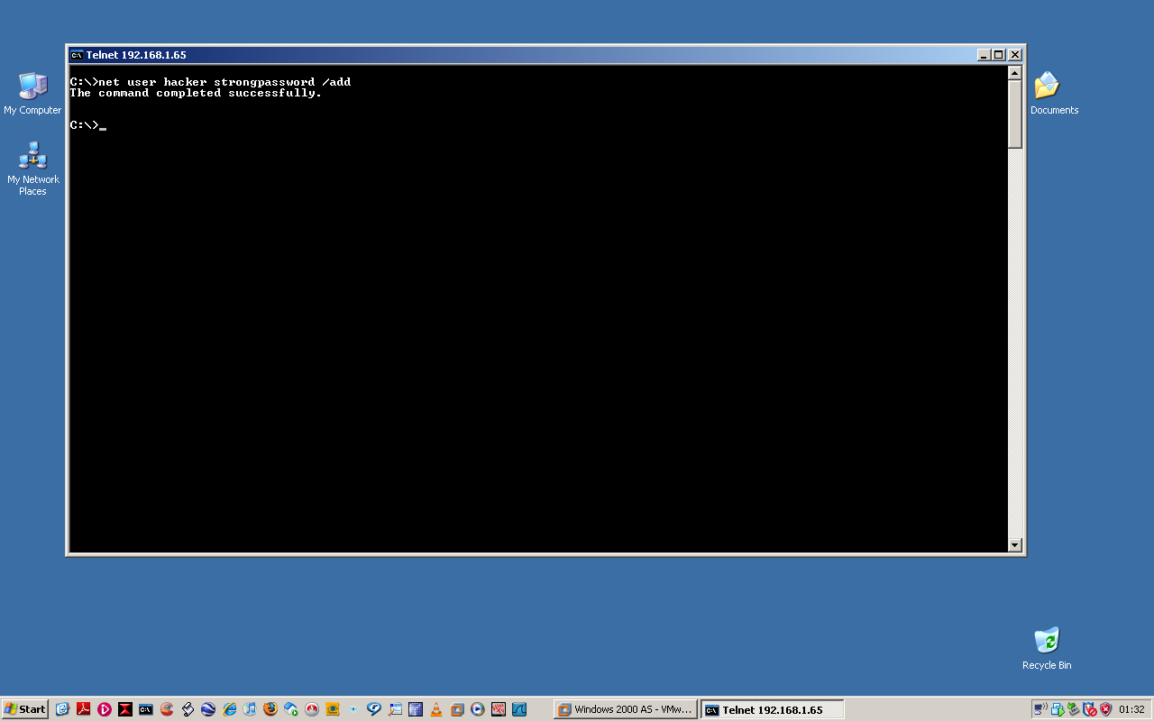 Figure 15
Whilst user access is sufficient, it gives the author a warm feeling if he is able to escalate his privilege from Domain User to Domain Admin – thankfully, the tester is of a similar mindset.

Figure 16 displays the syntax to escalate the user privileges from Domain Users to Domain Admins within the 0WN3D domain.
net group “Domain Admins” “hacker” /add /domain
Translated, the author has instructed the target to use the Domain Admins group (net group “Domain Admins” add the user account hacker to that group (“hacker” /add) specifically within the OWN3D domain (/domain).
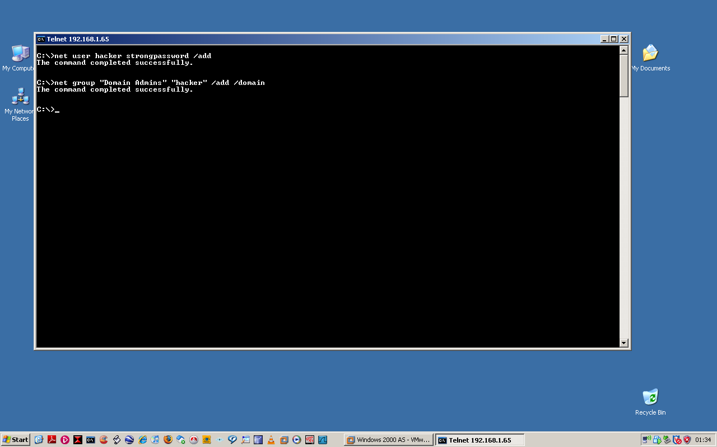 Figure 16
The target has now been compromised, with a Domain Administrator account created for further use by the tester.

NETWORK VULNERABILITY ANALYSIS

Discussion

In requesting a VA to be conducted against their infrastructure, an organisation has concluded the need to:
- Identify network vulnerabilities and mis-configurations.
- Detect and prioritise vulnerability exposure.
- Recommend remedies for detected vulnerabilities.
- Use targeted testing to eliminate false positives.
- Identify obscure emerging vulnerabilities without altering network configuration settings.
Anecdotal evidence suggests that almost every form of VA involves some form of risk (i.e. accidental interruption to system assets); however a tester should have a thorough understanding of all the tools within his armoury (open source and proprietary) prior to conducting the VA, ensuring that where possible he can maintain the integrity and availability of networked assets whilst providing an output which reflects an organisations requirement.
VA tools highlighted in this paper reflect a very small percentage of what is available to a tester, and whilst financial constraints may limit what tools are used, a good starting point on deciding what to use can be found from the Top 100 Network Security tools list, conversely the SANS Top 20 is updated annually to reflect what vulnerabilities are being exploited.
Organisations can benefit immensely from conducting a VA on its own infrastructure. In the authors experience only after a methodical and detailed VA has been conducted can weakness be identified and advice given of how rectification action can be implemented. Indeed some organisations employ their own testers, the benefits of which have been documented by Dr. Daniel Geer and John Harthorne“…using a dedicated team of penetration testers has all the advantages that accompany specialisation. Speed, cost and exhaustiveness are perhaps the most obvious and desirable…the possession of tools and methodologies clearly facilitates a more rapid analysis, which in turn reduces the cost of the analysis since…the tools, methodology and expertise of the team additionally ensure that analysis will be more thorough, meaning both that more errors will be found and that confidence is more justified where no errors are found”.(Geer and Harthorne, 2002 [online] [accessed 9 Oct 08]

NETWORK VULNERABILITY ANALYSIS
Conclusion

Performing a VA enables an organisation to identify threats and vulnerabilities to its infrastructure.
In order to safeguard an organisation, the asset and tester, logical and physical boundaries need to be clearly identified, defined, documented and signed before proceeding with any VA. Failure to establish the scope in advance may invalidate any test, lead to the wrong systems being assessed or compromised, whilst the worst case scenario may result in legal action being taken against the tester.
Reconnaissance whilst arduous and time consuming, is absolutely necessary to gather as much information as possible against the target system. In the rush to advertise and promote an organisations capability, an organisation, or associated partners may inadvertently release information which should be kept confidential. If this information can be used against the target, a tester’s role can be made easier.
Depending on the switch used (stealth or obtrusiveness), a port scan provides a fantastic picture of what services and ports are running on a system. Identification and knowledge of these ports and services enables the tester to focus his attack vector.
Enumeration provides a more granular and focused approach of conducting a VA. Vulnerability scanners (open source and commercial) provide detailed information on system platforms, applications, services, drives and shares. This detailed information allows the tester to report on vulnerabilities identified.
Access through ‘null session’ has been lessened considerably with the release of latter OS. However, if the human factor is responsible for a poor or mis-configuration of system, it shows how a relatively low level attack vector which can be used to exploit a system.
Regardless of whether a VA is being conducted by an individual or company, all tests should be conducted under the auspice of advice given by Harris, Harper, Eagle, Ness and Lester “the vulnerability test has the goal of providing a listing of all the vulnerabilities within a network…however no security professional should ever try to embarrass a customer or make them feel inadequate for their lack of security. This is why the security professional has been invited in to the environment. He is a guest and is there to help solve the problem, not point fingers. (Harris, Harper, et al 2005)

LIST OF ACRONYMS

CIAAN | Confidentiality, Integrity, Availability, Authentication, Non-Repudiation. | Page 4
VA | Vulnerability Analysis | Page 6
PT | Penetration Test | Page 6
OSSTMM | Open Source Security Testing Methodology Model | Page 6
CMA | Computer Misuse Act | Page 8
IP | Internet Protocol | Page 8
DNS | Domain Name Server | Page 10
MAC | Media Access Control | Page 12
UDP | User Datagram Protocol | Page 14
TCP | Transmission Control Protocol | Page 14
ICMP | Internet Control Message Protocol | Page 14
NetBIOS | Network Basic Input Output Service | Page 15
LDAP | Lightweight Directory Access Protocol | Page 15
SYN/ACK | Synchronised Sequence Number / Acknowledge | Page 15
OS | Operating System | Page 16
SNMP | Simple Network Management Protocol | Page 17
TCP/IP | Transmission Control Protocol/Internet Protocol | Page 19
SMB | Server Message Block | Page 20
IPC | Inter-Process Communication | Page 21
DC | Domain Controller | Page 22
MMC | Microsoft Management Console | Page 24

NETWORK VULNERABILITY ANALYSIS

BIBLIOGRAPHY - REFERENCES

Pete Hertzog, 2008, Open Source Security Testing Methodology Manual (OSSTMM), version 3, [online] [Accessed 10 Aug 2008] http://www.isecom.org/osstmm/
Great Britain. Parliament. 1990. Computer Misuse Act 1990, Chapter 18, Office of Public Sector Information, [online] [accessed 01 Sep 2008] http://www.opsi.gov.uk/acts/acts1990/UKpga_19900018_en_1.htm
ICANN http://www.icann.org/en/announcements/announcement-06mar07-en.htm/
Who supplied by Steve http://samspade.org/
McClure, Scambray, Kurtz, 2005, Hacking Exposed, Network Security Secrets and Solutions, Fifth Edition, California, McGraw-Hill/Osborne.
Wireshark supplied by Gerald Combs http://www.wireshark.org
The Internet Engineering Task Force (IETF), Request for Comments (RFC), Transmission Control Protocol RFC 793, User Datagram Protocol RFC 768, [online] [accessed 01 Aug 2008] http://www.ietf.org/rfc.html

NMAP supplied by Gordon Lyons (aka Fyodor) http://www.insecure.org
McClure, Scambray, Kurtz, 2005, Hacking Exposed, Network Security Secrets and Solutions, Fifth Edition, California, McGraw-Hill/Osborne.
Chris McNab, 2004, Network Security Assessment, California, O’Reilly.
Parziale, Britt, Davis, Forrester, Liu, Matthews, Rosselot, 2006, TCP/IP Tutorial and Technical Overview, Poughkeepsie NY, IBM.
Nessus supplied by Tenable Network Security http://www.nessus.org
Mitnick and Simon, 2002, The Art of Deception – Controlling the Human Element of Security, Indianapolis, Wiley.
Top 100 Security Tools List – [online] [accessed 01 Sep 08] http://sectools.org/
SANS Top 20 – [online] [accessed 01 Sep 08] http://www.sans.org/top20/
Geer and Harthorne, 2002, IEEE Annual Computer Security Applications Conference, Penetration Testing: A Duet, Page 7 [online] [accessed 9 Oct 08] http://breo.beds.ac.uk/
Harris, Harper, Eagle, Ness, Lester, 2005, Gray Hat Hacking – The Ethical Hacker’s Handbook, California, McGraw-Hill/Osborne.

