CIS002-6

APPLIED PROACTIVE NETWORK DEFENCE

DISCUSS HOW APPLIED PROACTIVE NETWORK DEFENCE CAN BE USED TO REDUCE THE VULNERABILITIES AND THE WEAKNESS IN THE SECURITY OF COMPUTER SYSTEMS THAT COULD BE EXPLOITED.

BY

CHRISTOPHER-CHARLES TAYLOR
(0811342)

COURSE TITLE: MSc Computer Security and Forensics (MSXCF)

TABLE OF CONTENTS

List of Figures. | Page 4
Abstract. | Page 5
Introduction. | Page 6
Chapter One – Minimising Services and Ports. | Page 7
Chapter Two – OS and Application Patching. | Page 8
Chapter Three – Anti Virus Software. | Page 9
Chapter Four – Intrusion Detection Systems. | Page 10
Chapter Five – Firewalls. | Page 12
Discussion. | Page 15
Conclusion. | Page 16
List of Acronyms. | Page 18
Bibliography – References. | Page 19

List of Figures

Figure 1 | Defence In Depth – Supplied by www.technet.com/ | Page 6
Figure 2 | OSI 7 Layer Model – Supplied by www.chipkin.com/ | Page 7
Figure 3 | NIDS architecture – Supplied by www.laralee.net/ | Page 10
Figure 4 | TCP packet – Supplied by www.electronicslab.com/ | Page 12
Figure 5 | ICMP packet – Supplied by http://images.cnblogs.com/ | Page 13
Figure 6 | UDP packet – Supplied by www.h3c.com/ | Page 13

Abstract
Applied proactive network defence aims to mitigate the threat of a network based attack to an acceptable level through a proactive response. Some measures, be they physical or virtual may impact on the functionality and ease of use of networked systems, therefore an appropriate level of defence must be balanced against the nature and value of the asset.

Threats to network infrastructures can originate from a wide range of sources, from physical and virtual hostile attack to a simple technical malfunction, or from mis-management of resources to misuse by individuals. The size, spread and complexity of some systems mean organisations as a whole are required to adopt a more proactive stance, such as routine monitoring and traffic analysis. As additional threats and vulnerabilities are identified further resources may be required depending on the asset value or business requirement.

Network defence can (and should) detect and respond to all threats; however it must apply maximum resources to those risks which represent the greatest loss to an organisation. In treating the risk, effective protection is also dependant on a comprehensive implementation of Information Assurance (IA) measures.

Applied proactive defence, in conjunction with IA supports and contributes towards wider information centric defence-in-depth strategy, which to be effective, must be conducted on a continual basis.

Introduction
The continued growth and expansion of connecting internal networks to external sources via the Internet has inevitably increased the opportunity for attack against an organisations electronic data and material. Protective controls, similar to those shown in Figure 1 below, aligned outward from the asset, need to be put in place to counter both threats and vulnerabilities to information and systems.
Many myths surround network defence, from thinking there is a “one stop solution” to providing a secure architecture to thinking that network security can be fully “achieved”. Unfortunately the network paradigm instigated by many organisations does more to dispel this notion than support it. Despite well-intentioned efforts to provide network security, the vast majority of security measures are “bolted-on” after-thoughts, which do nothing to relieve the complexity of managing or securing the asset or architecture.
Organisations have tried to approach network defence by focusing only on the perimeter, guarding against external threats using firewalls, Intrusion Detections Systems (IDS) and other variants. Whilst these devices provide a perimeter deterrent, they do not address threats from inside the organisation, and at times, create an expensive and complicated management framework. User’s perception of network security usually stops short at anti-virus products (to safeguard against worms or viruses), or by way of using firewalls to prevent network access to unauthorised users.
The truth is that applied proactive defence encompasses all of these things, and more.

The overall security of any system can be compromised by the “weakest link”, particularly in environments where security measures are being provided at different levels of the protocol hierarchy. Security personnel must have the resources and skills to detect and deter attacks whilst being able to manage the response adequately with the minimum of disruption to the organisation. All staff, regardless of position, must be flexible, learn from any incident and apply that experience in a proactive manner to reduce further attacks.

Proactive defence must address relevance, threat, vulnerability and impact. It must also ensure the asset is protected against compromise by the formulation and implementation of a written security policy.
It is important to recognise that effective applied proactive network defence is a process, not a product. Nor is it a case of applying the latest patch or running an occasional vulnerability scan. The dynamic nature of network security means security should be automated – so that the network itself can react to and repel threats.

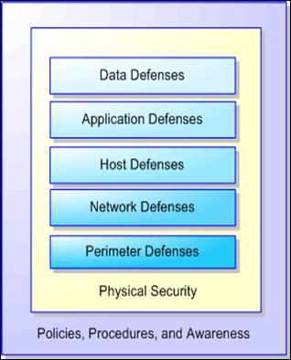 Figure 1 (Protective Controls aligned downward from the asset)

APPLIED PROACTIVE NETWORK DEFENCE

Chapter One – Minimising Services and Ports

A Service is a process or application that runs normally, although not exclusively, on a server to provide benefits to networked users (i.e. mail, data transfer and Internet access). Services are accessed by connecting to a specific port or socket, with a separate port number designated for each service or application running on the system. Port numbers range from 0-1023 (well known), 1024-49151 (registered), 49152-65535 (dynamic), and are allocated by the Internet Assigned Numbers Authority (IANA 2008). Brenton and Hunt (2003) discuss in greater detail how “the session layer is responsible for dealing with, establishing and maintaining the connection between two or more systems” whilst Figure 2 outlines where the Session layer fits into the Open System Interconnect (OSI) 7 layer model.

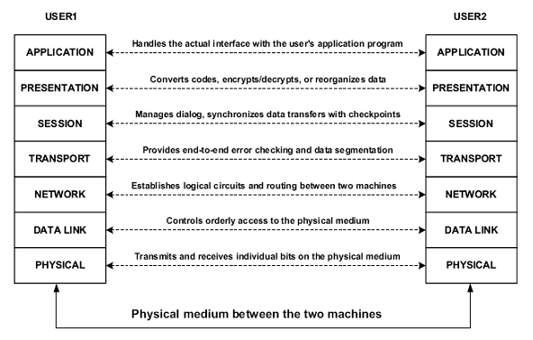 Figure 2 (OSI 7 Layer Model)
Open ports, whilst providing valid services, represent an attack vector which could be exploited by malicious users to gain unauthorised access to a computer. Therefore it is important to leave only the ports that you know are necessary for the central/core functions of network services, and for backward compatibility, any legacy systems deemed necessary. Furthermore, unnecessary applications and services left running on a system consume valuable system resources.
In order to minimise the footprint of a computer system, it is paramount that if ports and services are found to be redundant – then turn them off! Whilst in theory this may sound an obvious statement, it is important for an organisation to understand what ports and services are created during a default or bespoke installation of any new OS and associated applications. Only after identification is confirmed, can an organisation identify possible weak points and begin to minimise the attack vector.

Various protocols such as File Transfer Protocol (FTP) and Telnet pass their data in clear-text; as a result they are vulnerable to man-in-the middle attacks, making their use highly insecure. These ‘in-the-clear’ protocols should look to be replaced with a more secure access model such as Secure Shell (SSH). Disabling the use of these protocols greatly enhances the security of a system whilst retaining much if not all of the functionality. Where the use of these protocols is necessary, perhaps due to legacy support, financial constraints or a lack of resilience, then filtering these ports through a firewall, coupled with the suitable use of Access Control Lists (ACL), Media Access Control (MAC) filtering and TCP Wrappers can be used to minimise the attack vector.

Within the limits of a particular configuration, it is necessary to strike a balance between functional and security requirements. With added sophistication, software becomes more costly to produce and makes increasing demands on hardware and personnel resources. However, when implementing a software based solution, the principle of Least Capability (sometimes referred to as Least Privilege) should be adhered to. In short, users or processes acting on their behalf should only be given access to those functions essential for the specific task.
After minimising the amount of open ports and services on a system, where possible, the system should be rebooted in order to confirm that services which were previously closed do not re-start on power up.
APPLIED PROACTIVE NETWORK DEFENCE

Chapter Two – Operating System and Application Patching

The author has yet to meet a vendor who maintains their product is 100% secure 100% of the time. It is argued by the author that true application security can only be successful if the concept of security is incorporated into the initial design phase and followed continuously through the programming, developmental, production and post production process. However, until such times, as this is a realistic possibility, an organisation should ensure the software they use is current and up-to-date as per the vendor recommendations. Specifically this should include updates to the OS, applications, browsers, anti-virus protection (both engine and definition) and back-up software. It was observed by (Young and Atel, 2004) that “most application vulnerabilities can be addressed by adhering to the most current release of the software and diligently monitoring security and vendor sites for security patches, software releases, and exploit information”.

Furthermore, reducing the applications and minimising open services or ports on a system will help minimise the attack vector. Formulation of a documented and proactive patch management strategy is essential in ensuring software vulnerabilities are minimised. This will involve at the very least, the monitoring of vendor and open source information on new vulnerabilities. Software vulnerabilities stem from:

- Changes to software, resulting from the addition of new facilities or the correction of detected errors, are unavoidable and may inadvertently weaken the security controls, or cause some to be bypassed.
- The need for software changes may allow programmers to deliberately or inadvertently induce malfunctions, or organise the bypassing of security controls.
- Utility programs are often autonomous and as such, may be capable of circumventing security measures residing in the controlling or application software.
- Security loopholes may be caused through incomplete system design resulting from a lack of security awareness by system programmers.
- Supporting of different languages may open up a new attack vector.

Historically, people with malicious intent tended to exploit weaknesses and errors in network connectivity and OS; however defences against these attacks have improved over the years, in part due to vendor OS hardening tools and government security configuration guides being used, of note is the National Security Agency (NSA) configuration guides which have been developed to provide “…distributed configuration guidance for a wide variety of software from open source to proprietary software. The objective of the configuration guidance program is to provide NSA's customers with the best possible security options in the most widely used products”. The increased use of these guides, which are freely available, has focused attention further up the OSI stack toward applications and data files; the latter were once thought of as passive but are becoming a vehicle for malicious attack.

Unfortunately, patching, virus protection and boundary content filtering technologies are by their nature retrospective, and now that a new era in file formats has begun, security staff should look to educate their users on the validity of any such attachment. Organisations should look to educate their users to regard every attachment as suspicious (i.e. receiving attachments from unknown e-mail addresses, or with unusual file extension or naming convention).

Whilst it is conceded that vendor issued patches to fix bugs, add minor functionality or improve performance, can introduce additional problems or incompatibilities within an infrastructure, all patches should (resource permitting) be tested prior to being applied. As outlined earlier, an effective patch management strategy is a critical function in any organisation and a necessary, albeit difficult, part of managing the risk.

Only authorised changes to software should be permitted. These changes should be properly managed (i.e. documented change management procedure) and introduced to a system only after testing has been conducted and the configuration control documented.

APPLIED PROACTIVE NETWORK DEFENCE

Chapter Three – Anti Virus Software

Malicious Software is a generic term covering several types of software code introduced to a system to perform tasks which are not part of the system's designed functionality. Malicious software is generally intended to compromise systems confidentiality, corrupt its integrity or affect its availability. It is not to be confused with unexpected functions due to errors in software, mis-keying, or the misuse of OS commands.
The boundaries between different types of malicious software are not always clear-cut but generally they fall into one or more of the following areas:
- Virus – will normally attach itself to a valid object, allowing that object to perform its normal duties whilst infecting other objects and executing a harmless or malicious payload to other objects.

- Worms – are similar to viruses but reproduce in their entirety, creating exact copies of themselves without the need of a "carrier" program. That said, the advisory issued by the Computer Emergency Response Team (CERT) stated the Melissa virus “requires user interaction to propagate, therefore we do not consider it a worm. However, Melissa can propagate quickly from one computer to another with minimal interaction required by the user” (CERT, Accessed 31 Oct 2008. So the line between virus and worm is becoming less clear.

- Trojan horse – is a program which gives the appearance of providing normal functionality whilst performing another, unwanted action.

- Rootkits – useful for gaining and retaining unauthorised access to a system. Rootkits are ‘normally’ under the full control of a human being (i.e. the attacker), so strictly speaking they don’t fall into any of the above areas. They are perhaps described best by (Hoglund and Butler, 2006), “a rootkit is a set of programs and code that allow a permanent or consistent, undetectable presence on a computer”. In the authors opinion it cannot be underestimated how devastating the effect of a rootkit can have on a system. Personally, if a system is ‘rooted’, the author suggests that confidence can only be restored if the system is formatted and rebuilt.

In order to best combat the risk of malware being introduced into a system, an effective anti-virus policy is required, with the main planks being:

- Heuristic and ‘On-access’ scanning should be enabled on all systems using an up-to-date and reputable anti-virus product.

- Use software purchased only from a reputable vendor whilst implementing a software change and configuration procedure.

- Implement anti-virus awareness training for all personnel.

- Prohibit the use of software downloaded from external or un-trusted sources.

Where many files have been infected and the virus has been correctly identified, the use of disinfection utilities is provided by numerous vendors which considerably speed up and minimise the cost of recovery. In the case of widespread infection, it may be worth seeking additional guidance from the vendor which may reduce the cost of recovery.

Re-infection often occurs after the "clean-up" has been completed. Only thoroughness and attention to detail will reduce the risk of re-infection. Disk authorisation software, which writes soft marks on portable media, may also be employed to minimise the chance of this occurring. This type of software installed on a user's machine allows only media to be inputted with recognised soft marks.

Content scanners should be used at gateways to check that the format is as claimed, and mail servers and clients should be configured to block mail attachments with given extensions.

APPLIED PROACTIVE NETWORK DEFENCE

Chapter Four – Intrusion Detection Systems

Intruder detection systems (IDS), when correctly installed, configured, tested and deployed, offer the advantage of monitoring, detecting and responding to incidents or anomalies on a network. This information can be used by security staff to pinpoint attack vectors within their network. Unlike Intrusion Prevention Systems (IPS), IDS are normally passive in nature; there are 2 types which warrant attention.

Host Based IDS (HIDS)
HIDS attempt to identify unauthorised or anomalous behaviour on a specific system or device. HIDS generally involve installing an ‘agent’ on each system, which monitors and in some cases, alerts on local application and OS activity. The agent uses a combination of signatures, rules, and heuristics to identify unauthorised activity (i.e. file modification). HIDS are highly effective for detecting insider abuse, however with several hundred possible systems on a network, collation and aggregation of data may be inefficient.

Network Based IDS (NIDS)
NIDS analyses data and/or suspicious traffic travelling over a particular network. Positioned at strategic points within the network and normally located on a span port (in order that all traffic passing over the switch is captured) or on a dedicated network segment. This surveillance of these connections between computers makes NIDS ideal at detecting attempted access from an outside or un-trusted network.
HIDS and NIDS in Unison
Whilst both variants of IDS offer separate functionality, used in combination they offer an enhanced level of awareness. The HIDS based option ensure software on each hosts is constantly monitored, whilst the NIDS variant allows for the monitoring and collation of system audit trails in real time as well or on a scheduled basis, distributing CPU utilisation and reducing network overhead whilst providing a flexible means of security administration.
An organisation should, cost permitting, employ both variant of IDS. As cited by (Hay, Cid et al, 2008) “prevention is ideal, detection is a must”. Ideally, configuring both HIDS and NIDS to notify and alert in a similar fashion to a centralised point allows for less administrative overhead and an increase in reaction time should a network anomaly or possible compromise occur.
NIDS Placement
The author has learned through discussion (and often argument) that NIDS placement is a highly subjective matter. However, the author believes the NIDS placement shown in Figure 3 provides an acceptable level of protection to internal systems and border devices.
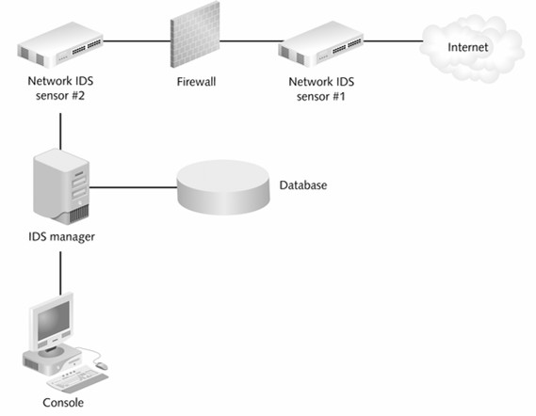 Figure 3 (NIDS on both sides of a firewall)
Sensor 1 should detect internet traffic that it has visibility of, and whilst it is conceded that a properly configured firewall should block unauthorised attempts to the internal network, the mere fact the IDS has detected a possible inbound attack gives an organisation time to implement their incident response plan.
Sensor 2 represents a more strategic placement, allowing the NIDS to highlight attacks which by-pass the firewall, and monitor the network traffic of third parties, or network access to sensitive resources which may present undesirable exposure general malicious intent. It should be noted that other NIDS are placed further into the network.
Both HIDS and NIDS have specific strengths and weaknesses (i.e. platform and vendor) all of which should be measured against the requirements for the organisations. However, regardless of the choice, an IDS solution should be incorporated in manner which can be centrally managed and which compliments other forms of network based security.

APPLIED PROACTIVE NETWORK DEFENCE

Chapter Five – Firewalls

Firewalls simply control what traffic is allowed across a certain point on a network based on a rule or policy. The name is taken from the firewall which is meant to prevent the spread of fire from one part of a structure to another. Firewalls perform numerous types of inspection, worthy of note are the following:

Stateless

Stateless firewalls monitor network traffic, whilst restricting or blocking packets based on source and destination addresses, port numbers or other static values. However, they treat each packet in isolation and have no awareness of traffic patterns or data flows, therefore, it is impossible to determine if a packet is part of an existing connection, establishing a new one, or whether the packet is rogue, yet it must decide to forward or discard the packet based on this limited information.
These types of firewalls are adept at looking at fields in packets and do so very quickly, however the speed comes at a trade-off. Given that no content filtering is carried out, this type of firewall can be easily fooled by many techniques which have been documented and automated.
However, stateless firewalls have useful role for handling the simplest forms of high speed attack before handing the packets to a more stringent form of inspection.
Stateful
Stateful firewalls focusing their attention on the Internet Protocol (IP) and Transmission Control Protocol (TCP) header characteristics. It should be noted however that stateful firewalls do not inspect the payload. The stateful firewall keeps track of all connections so it cannot be easily fooled. This type of firewall inspects the source address and source port, paired with destination address and port information and the ‘state’ flag. The state flag, outlined in Figure 4 defines the relationship between the source and destination address (and ports), showing the current connection status of that connection.
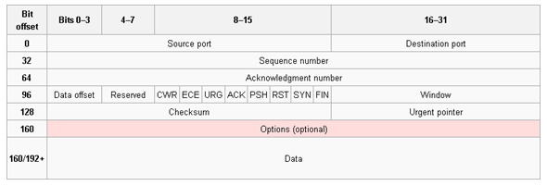 Figure 4 (TCP State Flags)
By keeping track of TCP connections, a stateful firewall can respond intelligently to packets arriving out-of-order, or packets that contain a malformed TCP flag. This improves on the functionality of a stateless firewall at the cost of additional overhead in maintaining a stateful tracking table for each connection through the firewall.
However, Figures 5 and 6 show that both Internet Control Messaging Protocol (ICMP) and User Datagram Protocol (UDP) do not have state flags, therefore for these types of protocols stateful firewalls rely on a timeout duration to determine when they can be safely removed from the ‘state table’. Once the timeout duration is exceeded, traffic from the external host will be dropped until another ICMP or UDP packet for the source or destination address and port originates on the inside of the network.

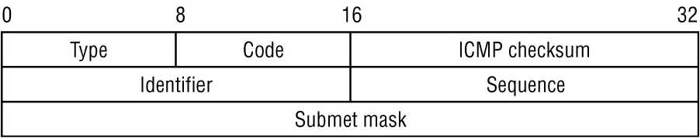 Figure 5 (Inside an ICMP Packet)
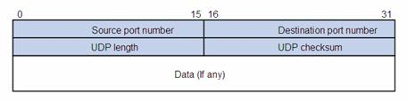Figure 6 (Inside a UDP Packet)
It is emphasised that regardless of the type of firewall used, the correct configuration is crucial to securing an adequate security posture. As remarked by (Henmi Lucas et al 2006), “a poorly configured firewall can leave gaping holes that a malicious person could walk through with ease”.

The configuration should be reflective of an organisations security policy and reviewed regularly, however as a minimum the following should be observed:

- The firewall should implement a “deny all services unless permitted” policy.

- Particular attention should be paid to properly maintained audit trails. Logging is one of the primary functions of the firewall, but care must be taken to ensure the logs do not fill up causing entries to be overwritten or logging to cease.

- The use of SAINT, Nessus, Firewalk and FTester should be used to check for known security holes in the firewall.

In order to fully exploit the audit logs, a balance between obtaining comprehensive logging and ease of analysis needs to be struck. Typically however, an organisation should look to log the following:

- Ingress and Egress attempts from non-standard or non-allowed ports or services.

- Attempted connections to insecure ports.

- Successful and unsuccessful connections.

- Error messages from firewall components.

- Multiple access attempts.

If the firewall has been compromised, one of the first things the author would do is to cover his tracks by doctoring the audit trail. If the firewall permits it, an organisation should configure it to use drop-safe logging, where the audit trail is copied to secure storage to prevent tampering.

There are various methods of configuring the firewall to raise an alarm as soon as suspicious activity is detected, a few of which are outlined below:

- Configure the firewall to e-mail or page the administrator when an alarm is triggered.

- On internal systems, a host may be configured to respond to all unallocated IP addresses on the subnet. The system could also be configured to alarm if any of the unallocated addresses are pinged (on the basis there is no need to contact them). This would detect address scanning attacks and also prevent IP spoofing attacks on the internal network. Either type of event may indicate the firewall has been breached and that an attacker is progressing to the network.

If an organisation has an internet facing firewall, it is almost inevitable that an attack will occur at some point. To that end, a contingency plan to cope with this situation must be formulated. Depending on the severity of the attack, there are 3 main approaches in dealing with this:

- Allow the attack to proceed and analyse it, with a view to tracking down and apprehending the attacker. In the authors opinion this approach is extremely risky, and should only be attempted only if the administrator is extremely confident of being able to terminate the attack before it is too late.

- Shut down any compromised machines. This approach is time consuming, and during an attack time is extremely valuable.

- Terminate the internet connection. This approach has the advantage that it can be performed quickly, and causes the minimum of disruptions to your users. It is perhaps this approach the author would advocate, however it requires that security staff have visibility of the link.

As a minimum, a suitable firewall should support the following security functions:

- Management should be restricted to the console or over a trusted path and with strong authentication.

- In the event of a power failure the firewall should fail-safe (i.e. close connections) and act as an air-gap when inoperative.

- Capable of hiding details of the internal network to the outside world (i.e. through Network Address Translation (NAT) and mail header rewriting).

- Control access based upon network services.

APPLIED PROACTIVE NETWORK DEFENCE

DISCUSSION

As pointed out by (Brenton and Hunt, 2003) “When you teach users how to interact with the new rules and technologies that have been put in place, they will become comfortable with them and accepting of them. Once they understand the system, users will embrace it becoming proactive in carrying…security into all facets of their work”. To that end, user education and training is critical in identifying targeted attacks against an organisation and its personnel. Users should be educated and instructed never to divulge personal information via the telephone or e-mail. Furthermore, the opening of suspect e-mail attachments from senders unknown should also be regarded as bad practice. Vulnerabilities on a computer may be exploited simply because similar computers share similar vulnerabilities, human beings however are different – while 10 people in an organisation will give out their password when asked, there are 10 more that won't; it just depends how you ask them; social engineering is a people problem, not a technical one.

Business Continuity Management (BCM) focuses on the impact of disruption, identifying those products and services on which the organisation depends for its survival, and what is required for the organisation to continue to meet its obligations and deliver its outputs. BCM is as much a proactive discipline as a reactive one. Whilst it is preferable to avoid the impact of a disruptive event than to successfully recover from it, all staff should be encouraged to think about the continuity consequences of their day-to-day decisions, and publicly praised for good decision-making that results in an overall improvement to local resilience.

Organisations should also consider establishing a Control of Entry (COE) mechanism designed to protect the confidentiality and integrity of both asset and infrastructure. The COE procedure should include plans to deal with unauthorised visitors or intruders to the establishment whilst outlining that unescorted visitors must at all times be subject to the degree of control necessary to prevent any unauthorised access to assets or infrastructure. Only after visitors have been positively identified (and have a legitimate reason to have physical access to the asset) should they be afforded access.

Additionally, organisations who connect their internal systems to the internet, should document this connectivity, alongside an acceptable use policy in the context of a written security policy. The importance of such a policy cannot be over emphasised. As a minimum it should define the aims with respect to security and set constraints on exactly what services the connection will allow. Furthermore, incident handling procedures in the event of a compromise should also be documented. Security staff should be assigned to install and configure the network connection in-line with the current security policy and as a basis for setting up the necessary physical controls to ensure the risk is properly managed.

APPLIED PROACTIVE NETWORK DEFENCE

CONCLUSION

Proactive network defence is a dynamic and continuing process – not a one stop shop solution. Using an information centric defence in depth strategy, that is implementing layers of defence outwardly from the asset, the following measures should be adopted to protect both the asset and the wider network infrastructure:

- Minimise the footprint of systems by reducing the amount of services and ports being used.

- Formulate, document and implement an effective patching strategy to reduce the number of platform and application specific vulnerabilities.

- Reputable anti-virus products should be used to minimise the risk of importing malicious or defective software. Updated (both engine and definition) regularly, it should have an appropriate level of scanning initiated dependant on the asset.

- Host and Network Based Intrusion Detection Systems should be used together for advance warning of external and internal attacks.

- Firewall deployment, installation and configuration although complex is a vital component in revealing whether an organisation systems are under attack and must be regularly monitored and updated.

- Newly procured software should be tested in isolation prior to being introduced to the network.

- Continuous user education is critical in safeguarding the network, particularly regarding divulging usernames and password over the telephone or email.

- Users should be discouraged from executing arbitrary pieces of software they receive from external sources (i.e. suspicious or unknown e-mail attachments).

- Business Continuity Management is a vital process which should be documented and exercised on a regular basis.

- Restriction of movement and access to the asset should be drawn up via a COE procedure.

- An acceptable use policy, which should form part of an overall security policy should be documented an all users should signed as having read.

LIST OF ACRONYMS

IA | Information Assurance | Page 5
IDS | Intrusion Detection System | Page 6
ACL | Access Control List | Page 7
FTP | File Transfer Protocol | Page 7
MAC | Media Access Control | Page 7
OS | Operating System | Page 7
OSI | Open System Interconnect | Page 7
SSH | Secure Shell | Page 7
CERT | Computer Emergency Response Team | Page 9
HIDS | Host (based) Intrusion Detection System | Page 10
IPS | Intrusion Prevention System | Page 10
NIDS | Network (based) Intrusion Detection System | Page 10
IP | Internet Protocol | Page 12
TCP | Transmission Control Protocol | Page 12
COPS | Computer Oracle and Password System | Page 14
NAT | Network Address Translation | Page 14
SATAN | Security Administrators Tool for Analysing Networks | Page 14
BCM | Backup Continuity Management | Page 15
COE | Control Of Entry | Page 15

APPLIED PROACTIVE NETWORK DEFENCE

BIBLIOGRAPHY – REFERENCES

Internet Assigned Numbers Authority 2008, [online] [accessed 29 Oct 08] http://www.iana.org/assignments/port-numbers

Brenton and Hunt, 2003, Mastering Network Security 2nd Edition, San Francisco, Sybex
Young and Atel, 2004, The Hacker’s Handbook; The Strategy Behind Breaking Into and Defending Networks, Florida, Auerbach

National Security Agency (NSA) – [online] [accessed 15 Oct 08] http://www.nsa.gov/snac/downloads_all.cfm/

Computer Emergency Response Team (CERT) – [online] [accessed 31 Oct 08] http://www.cert.org/advisories/CA-1999-04.html/

Hoglund and Butler, 2006, Rootkits – Subverting the Windows Kernel, USA, Addison-Weasley
Hay, Cid and Bray, 2008, OSSEC HIDS; Host Based Intrusion Detection Guide, Burlington, Syngress.
Henmi, Lucas, Singh, Cantrell, 2006, Firewall Policies and VPN Configurations, Rockland, Syngress
Brenton and Hunt, 2003, Mastering Network Security 2nd Edition, San Francisco, Sybex

